wendy k. rasmussen
MKTC 1000 – 59 Principles Of Marketing
Marketing Plan, Complete
November 30, 2018

Introduction
Nifty Tissues is a business that designs distinctive designs for tissue boxes and will allow customers to buy them a la carte or in bulk. Nifty Tissues will also provide the service of letting the customer design their own tissue box patterns. This business will originate out of Saint Louis Park, Minnesota.
Mission Statement
To allow our customers to express themselves using our unique designs and high quality tissues.
Marketing
The ideal customer of Nifty Tissues will live in upscale areas in major metropolitan areas in the United States and Canada. Clients could potentially be other businesses using our service for their own marketing.
The Internet will be vital to launching this product, especially through word-of-mouth on social media. A web site will be created and maintained by the company. Perhaps at one point direct mail will be utilized.
Environmental Factors
Changing demographics will mean that our product will have to change and evolve as well. Cultural considerations will be taken when choosing designs for possible sale on our tissue boxes. Environmental factors will mean that Nifty Tissues may use recycled paper as much as possible. Technology these days requires that our website be state of the art.
Competition
The main competitors for Nifty Tissues will be Kleenex and Puffs, with indirect competition from discount retailers’ own private brands of tissues. Possible threats could possibly be that websites like Zazzle.com or CaféPress.com would launch their own custom tissue boxes.
Our Competitors
Our primary competitors will be Kleenex and Puffs. Secondary competitors will be Scotties, and Private Brands for discount retailers. According to Statista.com. Kleenex and Puffs together cornered 64% of the tissue market in 2017.
About Kleenex
Kleenex is a brand owned by Kimberley-Clark Worldwide. According to Statista.com, 167 million people bought at least one box of Kleenex in 2017. A single box of Kleenex sells at Target locally for $1.59 (Target.com).
About Puffs
Puffs is manufactured by Proctor & Gamble. Again, according to Statista.com. 55 million people bought at least one box of Puffs in 2017. Walmart sells single boxes of Puffs for $1.34 (Walmart.com)
About Private Brands
39.98 million people bought boxes of facial tissues from discount retailers such as Target and Walmart, or grocery stores like Cub or Aldi (Statista.com). Prices per box vary, but are comparable to Kleenex and Puffs.
About Scotties
Scotties Tissues are owned by Irving Brands. I was unable to locate a price for a single box on Target’s, Walmart’s HyVee’s, or Amazon’s sites. 16.65 million people bought at least one box of Scotties in 2017 (Statista.com)
Nifty Tissues’ Competitive Advantage
The competitive advantage will be that the company’s tissue boxes will have unique and desired designs. Plus, our company can give the customer exactly what they want with design-it-yourself boxes, for which it is believed customers will pay extra for.
Information on the Tissue Industry in General:
According to Esko Uutela, the “Guru” of tissue, the industry expects growth of 3.5% annually. Although the growth will not be consistent among all world markets. Much of the growth is coming from the developing world, especially in China. (Found on Andritz.com.) The Asian market will overtake the North American market as bringing the highest facial tissue sales by 2025. “Indirect Distribution (Retail Pharmacies, Drugstores, Supermarkets, Convenience Stores, E-commerce) is the largest segment [globally], expected to hold 3/4th of the global market share by the end of the forecast period in 2025.” (sbwire.com)
Demographic Information
The company plans to be just a website first. But if the company is successful enough to launch a bricks-and-mortar location, Minneapolis would be a good place to start. 2.9 million people live here. The median income in in Minneapolis is $52.611. Women make up 49.4% of the population. Minneapolis has grown in size; 10.4% from 2010 to 2017. The greater Hennepin County area had almost $24 million in retail sales in 2012 ($20,199 per capita). So, it is likely that there is a willingness to buy here. (source: Census.gov)
Strengths:  Unique designs | Opportunities:  Finding and expanding new target markets
Weaknesses:  Cost of obtaining quality facial tissue could hinder growth (at least at first) | Threats:  One or more of our competitors may start their own access to design-your-own boxes

Questions Used In Our Market Research Survey
- Being able to express myself creatively is important to me.
- True.
- False.

- Would you like to be able to have a box of facial tissue with your own design on the box?
- Yes.
- No.

- How much would you pay for a box of tissues with your own design on it?
- Less than $1.50.
- $1.51 to $2.00.
- More than $2.00.
- I would not pay for this product at any price.

- What brand of facial tissue do you typically buy?
- Kleenex
- Puffs
- Scotties
- Discount store/supermarket house brand
- Other (please specify): ______________________________________

- What neighborhood in Minneapolis would be most convenient to you to visit a Nifty Tissues store?
- Loring Park.
- Lowry Hill.
- Lyn-Lake/Uptown.
- Other: (please specify) _______________________________________

- What social media services do you use frequently? (Check all that apply.)
- Facebook.
- Twitter.
- Instagram.
- Pinterest.
- Reddit.
- Other or others (please specify): _______________________________

- Which search engine do you use the most?
- Google.
- Bing.
- Yahoo.
- DuckDuckGo.
- AOL.
- Other (please specify): _________________________________________

- Do you prefer to shop online or in a physical store?
- I prefer to shop online.
- I prefer to shop in a physical store.
- Either / No preference

- I would like to have a box of facial tissue with my favorite sports team’s logo on it.
- True
- False

- Do you read a local newspaper?
- Yes, I read the StarTribune.
- Yes, I read the Pioneer Press.
- Yes, I read City Pages.
- Yes I read another paper (please specify): ___________________________
- Yes, I read more than one paper.
- No, I do not read a local newspaper.

- How much would pay for shipping?
- A small amount is acceptable.
- Whatever it costs to ship my purchase.
- I expect free shipping.

- Which age bracket do you fall into?
- Under 25.
- 26-35.
- 36-45.
- 46-55.
- 55 and over.

- What is your marital status?
- Never Married
- Married
- Divorced/Widowed

- Do you have children?
- Yes
- No

- How many boxes of facial tissue do you usually buy in a year?
- None.
- 1-5.
- 5-10.
- 11-15.
- More than 15.
Marketing Research Survey Results
Nifty Tissues conducted a survey on SurveyMonkey.com between the dates of 09/30/2018 and 10/02/2018. The survey was advertised on both Twitter and Facebook. There were 28 respondents. The respondents answered that there would be overwhelming demand for this product. 85.71% said that yes, they would like to purchase a box of tissues with their own design on the box. Between $1.51 and $2.00 is what the respondents decided was a good price for this product.
The vast majority (75%) said they would pay a small amount to have these custom boxes shipped. Which is good because the respondents said that they prefer to shop online (46.43%). (32.14% had no preference as to whether they preferred to shop online or in a physical store.) There was no clear winner in where a physical store should be set up.
As for promotion for Nifty Tissues, the majority said that they did not read a local newspaper. So, advertising in the StarTribune and/or Pioneer Press may be a waste of resources. The survey indicates that Facebook (42.86%) and Twitter (50%) would be good places in which to advertise this product. 92% said that they use Google, so it would indicate that a web presence should be built there.
If one was to determine a target demographic at this point, it would indicate that Nifty Tissues’ ideal buyer is between the ages of 46-55, married and has kids. (Gender and race were not polled.) This person buys more than 15 boxes of tissue per year and they feel that being creative is important to them.
Product Life Cycle
Nifty Tissues is a brand of facial tissue that allows consumers to design the pattern on the sides of the box. A possible box could look like this:
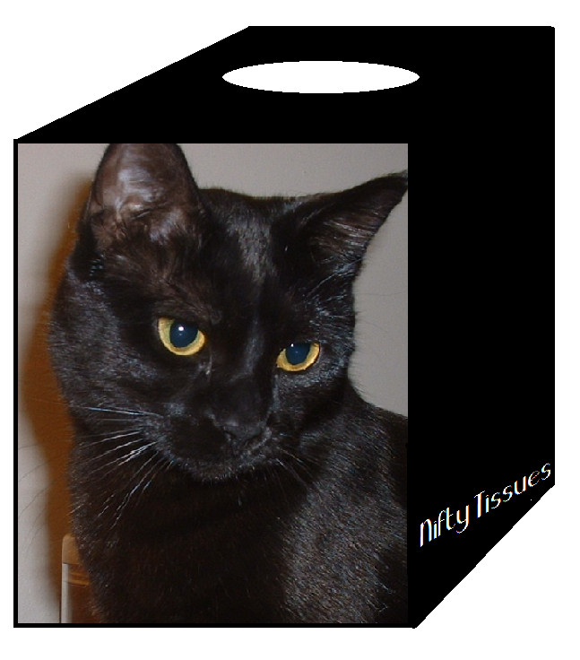
Nifty Tissues could be both an industrial product and a consumer product. Businesses may want facial tissues with their corporate logo on it, while a consumer family may want a picture of themselves on a box.
Nifty Tissues is a new-to-world product entering the introduction stage of the product life cycle. Start up costs for Nifty Tissues could be high, but that will be determined by the business analysis. Nifty Tissues may lose money at first because of said start up costs, but if there is adequate investment in promotion Nifty Tissues will enter the growth stage and start up costs will be recouped.
Distribution Strategy
Having a social media presence will be the bulk of our advertising, because word-of-mouth can be an effective marketing tool. Perhaps banner ads on certain popular websites can be effective.
Nifty Tissues will have an exclusive distribution strategy at first, while the business is in the infancy stage. Once growth is achieved (or has gotten to a good point), marketing can expanded out to selective.
A wholesaler may not be needed for proper distribution, if a direct link from the manufacturer can be achieved. Nifty Tissues will not be a large operation, at least not at first.
Nifty Tissues plans to be online only at first, but it is possible that Nifty Tissues could be a specialty shop and sell direct to consumers. The nature of a personalized product cannot be mass produced.
Promotion Strategy
Nifty Tissues will have a social media presence, since our survey indicated that most of our target audience is online. There will be a Facebook page, a Twitter handle, an Instagram account, and even a Pinterest page where satisfied customers could possibly post photos of the personalized boxes they have purchased from us.
The advertisements will be simple, with green and black (because green is calming and because black lets the white text show up better). The ads will feature the mascot for Nifty Tissues, Zoey the Cat. The name of the font used is Honey Script. It has a retro, kitschy feel that the target audience may get into.
Nifty Tissues will also place banner ads on major websites. Adwords will be placed on Google and other search sites. For more non-traditional advertising, perhaps advertising on the sides of Metro Transit buses could work since our target market lives in a metro area and is likely to see them when out and about.

As far as public relations, perhaps Nifty Tissues can print up boxes with the logos for local news outlets to be sent to them in order for them to possibly do pieces on the product.
To jumpstart sales, Nifty Tissues will offer a 50 cent off coupon to the first 10,000 people who visit NiftyTissues.com. This strategy will be deemed successful when after 6 months’ time 5,000 of those coupons have been redeemed. Also, another market research study will be conducted to determine brand awareness.
Pricing Strategy
At first Nifty Tissues will have an exclusive distribution, and therefore shall have an exclusive price. Skimming (at least at first) seems like a good way to go to create, develop, and maintain a quality product.
It seems that the competitors for Nifty Tissues have somewhat similar costs per tissue; 1 to 3 cents. However, Seventh Generation thinks they can charge 5 cents per tissue.
Brand Name | Qty of Tissues Per Box | Price Per Box | Cost per tissue
Kleenex | 75 ct | $1.99 (Cub/Instacart.com) | 2.6 cents
Puffs | 48 ct | $1.49 (Cub/Instacart.com) | 3 cents
Essential Everyday (Cub house brand) | 74 ct | $1.49 (Cub/Instacart.com) | 2 cents
Willow (ALDI house brand) | 75 ct | $1.35 (ALDI/Instacart.com) | 1.8 cents
Target house brand | No single box sold  on target.com | --------- | -----
Seventh Generation | 85 ct | $4.36 (Walmart.com) | 5.1 cents

In the market research survey conducted earlier in this term, 46% of respondents said that they would pay between $1.51 and $2 per box, with 28% saying they would pay more than $2. Perhaps Nifty Tissues could get away with a higher price, if only to pay artists good money to create unique designs that people will want (for those who don’t know what they would customize their boxes with). Once Nifty Tissues became established and perhaps faced some competition, the price will have to come down a bit to spur and then maintain growth. The $2.50 - $3 range sounds like a good place to start.

