wendy k. rasmussen
MKTC 2000-59 Advertising Practices and Procedures
Semester Project In Its Entirety
May 10, 2019

Profile
Macy’s is one of the largest department store chains in America, with 875 locations. It was originally founded by Rowland Hussey Macy as R. H. Macy & Co. in 1858. Macy’s has the following subsidiaries:
- Macy's Backstage
- Bloomingdale's
- Bloomingdale's Outlets
- Bluemercury
- STORY
Women are the main demographic that shops at Macy’s. 1/3rd of these women have children under the age of 18. In the recent past, Macy’s has tried to specifically market to Hispanic and millennial-aged customers. Macy’s has over 20 private-label brands and has a rotation of limited-edition celebrity brands. Many of Macy’s customers love the trendy fashions at a good perceived value, but they are dissatisfied with disorganized stores and a lack of service. Macy’s, like department stores in general, is trying to stem a downward slide in sales.
Budget: $500,000 for the duration of the second quarter of 2019; to be utilized for the Minneapolis/St. Paul market.
Objective: To invite customers back to Macy’s, in order to increase sales by 3% during the second quarter of 2019.

Market Research
According to the research conducted for this campaign, the target consumer is part of the follow demographic segments:
- Female
- Between the ages of 40-54 (Generation X)
- Has no children
- Makes between $25,000 and $75,000.
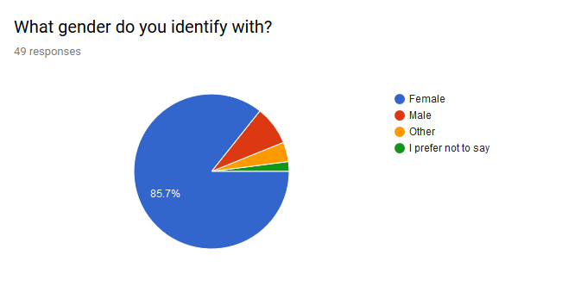
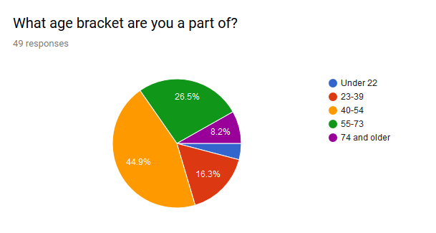
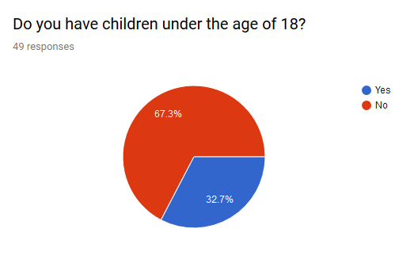
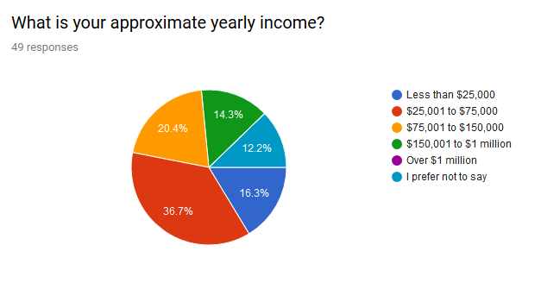
Also, according to the research, Macy’s is not our target market’s first choice in clothing retailers. The survey indicated that discount retailers such as Target and Walmart are their primary choice and that this demographic purchases one or two items a year.
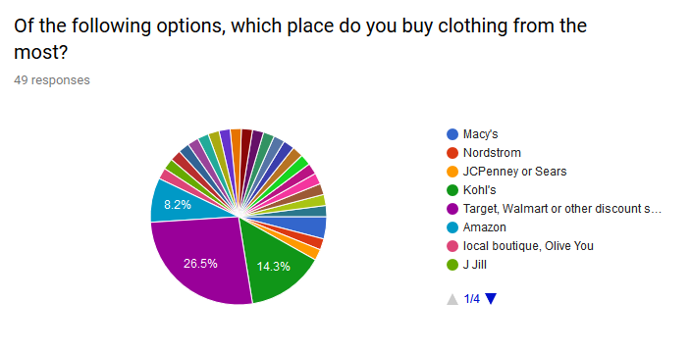
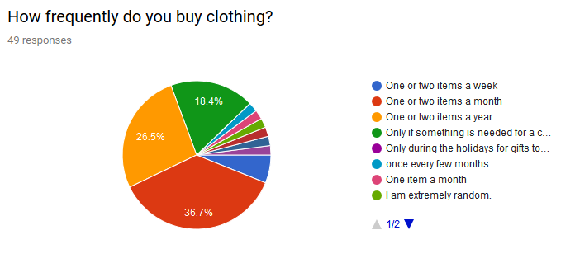
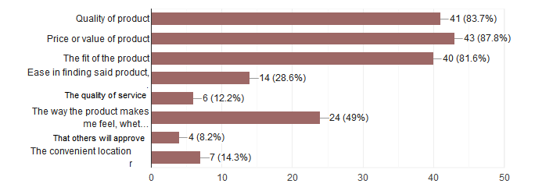
Getting a quality product at a good price or value is of utmost importance to this group. They also are concerned that items fit well. They are not concerned so much about purchasing brand names or being trendy. They do like a store that has many brands to choose from, however. Our respondents said that they do not buy items at full price. Macy’s also needs to change the perception that Macy’s only has high cost brands. Macy’s has over 20 private label brands. Perhaps this fact should be accentuated, along with the fact that many of these brands are low cost but high quality. Diversity in options and prices are a strong point for Macy’s and it makes them unique. A sizable amount also indicated that they buy items that make them feel good. Maybe Macy’s can find a way to tap into this.
As far as media strategy, Macy’s has traditionally purchased full page ads in local newspapers. The research indicates that 51% of respondents subscribe to a local paper. It would be wise to continue this practice but perhaps the amount spent should be scaled back.
59.2% of respondents listen to local radio; many of them listen to news radio. So perhaps sponsoring Minnesota Public Radio programming or buying ad time on WCCO-AM would be a good idea. There were also several other music stations listed among survey respondents.
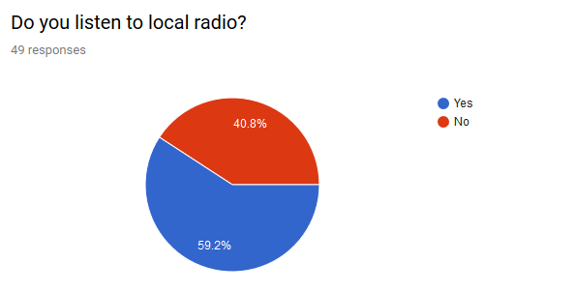
As far as television consumption, Netflix is the most watched. However, they do not take advertising. Respondents also indicated that they watch local broadcast affiliates. People also watch cable but did not indicate overwhelmingly which specific networks to target.
With social media, the top 4 platforms that respondents frequent are:
- Facebook
- Twitter
- Instagram
- Pinterest
Macy’s recently stated that they now spend the majority of their ad dollars on Internet and digital marketing. It would be wise to maintain (if not increase) this trend.
Many of our respondents read magazines, but a lot of them read those that are not fashion oriented. Perhaps Macy’s should decrease magazine advertising because they may not reach a sizable amount of people.
The vast majority of respondents use an automobile for transportation. Macy’s should perhaps look into billboard advertising, or even the sides of buses. People will see them when they are stuck in traffic.
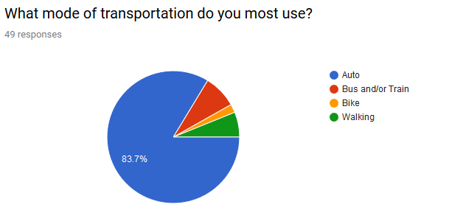
If Macy’s can find a way to shake off the perception that they are expensive and establish that they have many brands to choose from, perhaps our target market will be willing to at least try Macy’s again.

Marketing Strategy
Macy’s wants to be known as America’s Department Store. America is made up of many diverse cultures. Our ads will appeal to people’s sense of patriotism by celebrating America and its people. Our customers can celebrate themselves through their purchases.
Macy’s is made up of many diverse private brands, and our merchandise has a diversity in not only its styles, but its range of price points. We feel that anyone can find something they love when they shop at Macy’s and get a bargain on it. Also, we feel the quality of our merchandise is higher than other department stores, so we should emphasize our value.
Our message will try to tie together the diversity of the American people and the diversity of our products. We want people to discover Macy’s or re-discover it. We want people to know that everyone is welcome to shop here. We want to appeal to our target market’s emotions by giving the impression that purchasing our merchandise “sparks joy”. But without using those exact words.
Objective: To invite customers back to Macy’s, in order to increase sales by 3% during the second quarter of 2019.
Budget: $500,000 for the duration of the second quarter of 2019; to be utilized for the Minneapolis/St. Paul market.
For the next few months, we will focus on the following venues for advertising:
- StarTribune.com
- The St. Paul Pioneer Press
- Metro Transit
- Sponsoring Minnesota Public Radio
- Google Display Network
Some of these advertising mechanisms Macy’s has not previously tried in the past. Perhaps if we advertise in unexpected places it might get more people’s attention.
Print Advertising
Traditionally, Macy’s has purchased a full page ad in both the StarTribune and the Pioneer Press every day for years, if not decades (when it was Dayton’s then Marshall Field’s). While our target market still subscribes to these papers, readership of the physical paper is down. We would be better off advertising on startribune.com. People gloss over ads they see every day. But if we scale down to only the weekends in the Pioneer Press, we may get noticed more. Besides, there is no longer a Macy’s in downtown St. Paul.
- Minneapolis StarTribune
The StarTribune claims that 8 million unique visitors visit startribune.com every month. The rate for a half page ad on startribune.com is $15 CPM. So, to reach that many people, we will need to spend $120,000.
- The Saint Paul Pioneer Press
A full page advertisement that would run on Sundays during the 13 week duration would cost $14,616.
Advertising through Metro Transit
Intersection, the agency that handles bus and rail advertising for Metro Transit, claims that they are seen by 96% of the metro area, or 400 million times weekly. Renting space on the sides of 25 Metro Transit buses will cost during the 3 month period: $270,000. It is claimed that the four-week GRP is 321.
Sponsoring Minnesota Public Radio
The average rate on MPR News Monday through Sunday (6AM-12 Midnight) is $260. So, if we sponsor it daily for the duration of the second quarter of 2019, the cost would be $23,400. To purchase an ad on MPR.org would cost $840. But it will be seen by 60,000 people, which would make the cost $14 per thousand.
Google Display Network
We will spend $72,960, or $600 per day (on average for the 121.6 day period in the fiscal quarter), on online advertising by working with Google through their advertising network, search engine and subsidiary companies. We will focus on viewable impressions (cost per thousand) because we are trying to maintain (if not increase) awareness of our company. Through Google we can target the Twin Cities area and try to reach our target market within.

This will be our final budget.
StarTribune: $120,000
Pioneer Press: $14,616
Metro Transit: $270,000
MN Public Radio: $24,240
Google Display Network: $72,960
Total: $501,816

Spring 2019 Advertising Campaign
Here are the promotional tools/advertisements that will be used for the 2019 2Q campaign for Macy’s in the Minneapolis & Saint Paul markets.
The following slogan will be implemented: “Celebrate America. Celebrate You.” The fonts used are: Magnolia Sky (slogan font), ITC Avant Garde Gothic Standard for standard text, ITC Avant Garde Gothic Medium for accentuated text, and Arial to create the stars in the newspaper ad.
The first medium we will advertise on will be StarTribune.com. This is the 300x600 pixel ad as it would look on the webpage. (see below)
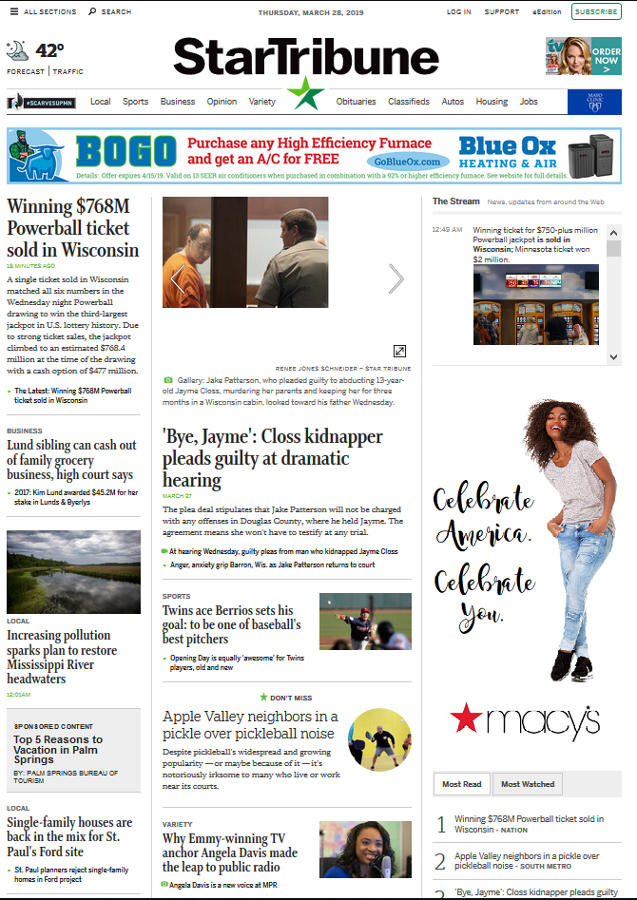
The second avenue for our campaign is a full-page print ad in the Saint Paul Pioneer Press that will run weekly. Here is a mockup:
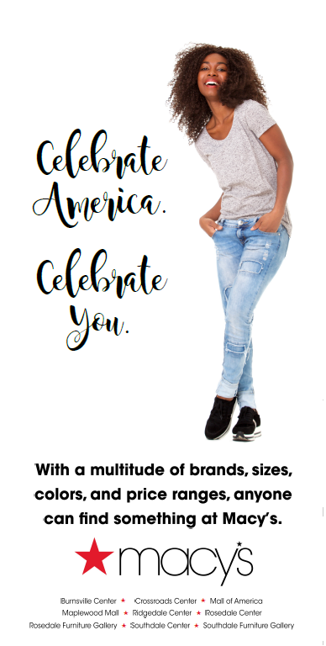

The third place we will be advertising is through sponsorship of Minnesota Public Radio. Proposed radio script:
“Programming on Minnesota Public Radio today is sponsored by Macy’s. With a wide variety of brands, styles and price ranges, anyone can find something at Macy’s. Eight locations in the metro area. Celebrate America. Celebrate You.”
Another ad will appear on mpr.org. Here is what it might look like:
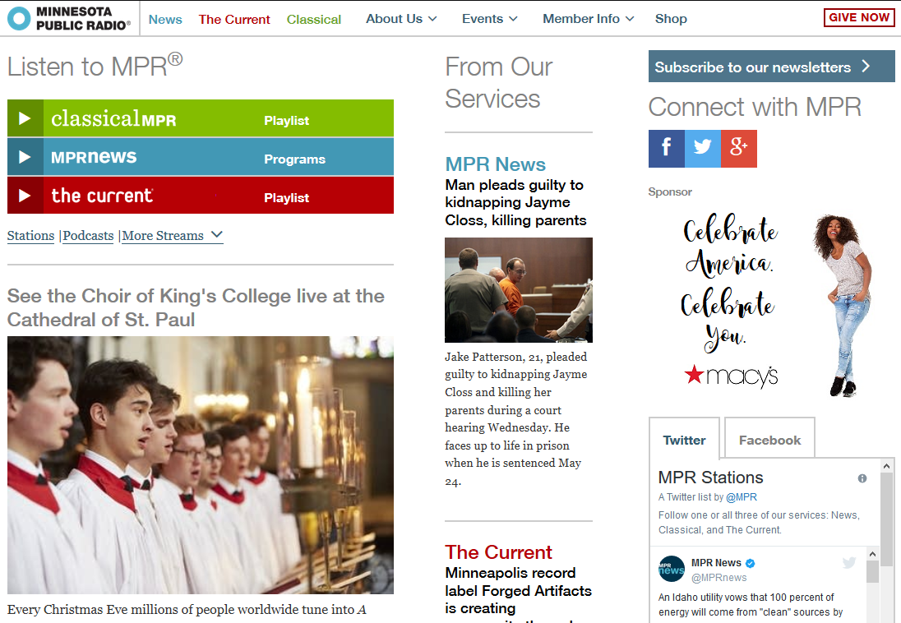
Our campaign also hopes to reach our audience is via Metro Transit buses. The following is an example.
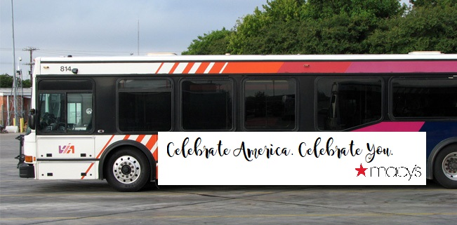
Finally, we will be utilizing Google to spread the word. Below are ads that fit the most standard Google sizes that will work with most computers, tablets and smartphones.
300 x 250:
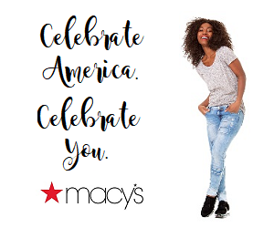
300 x 600:
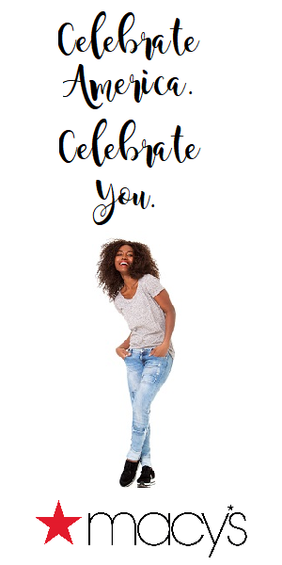
336 x 280:
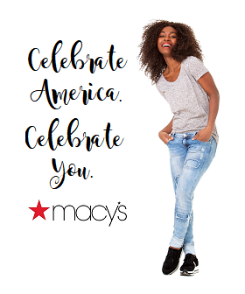
250 x 250:
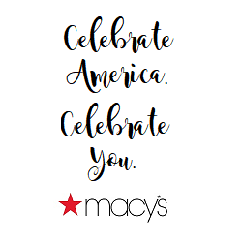
200 x 200:
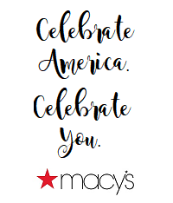
160 x 600:
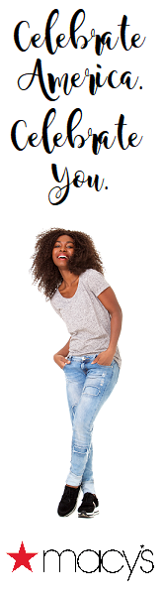
320 x 50:
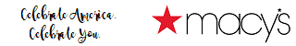
320 x 100:

468 x 60:

728 x 90:

And 970 x 90.
What our ads might look like on YouTube:
