Company Profile
Volkswagen is an automaker headquartered in Wolfsburg, Germany. They are also known for their other brands: Audi, Porsche and Lamborghini, among others. They are Europe’s largest automaker, and the second largest manufacturer worldwide. Volkswagen currently employs 656,000 people. Over 363 thousand Volkswagen cars were sold in the US last year. In 2015, the Environmental Protection Agency found that Volkswagen had installed software in their cars to cause them to deceptively report lower levels of emissions, violating the Clean Air Act. Volkswagen was forced to recall about 482,000 cars and was also forced to pay a settlement of $15.3 billion to its customers and $1.2 billion to its dealers the following year. In 2017, Volkswagen announced that by 2025 they plan to launch electric versions of 30 of their vehicles. This document will create and implement publicity for the launch of the electric version of the VW Beetle, in particular.
Objectives of the Publicity Campaign
- To increase awareness of VW’s new all-electric vehicles by introducing the all-electric Beetle.
- To improve public opinion about Volkswagen.
- To persuade 25% of people who own older Beetles to retrofit to electric.
- To show government regulators, environmental groups and the general public that Volkswagen is now compliant with environmental regulations.

This campaign should remind people why they love Volkswagen, causing them to move past the scandal and come back to/stay with Volkswagen, helping them overtake Toyota as the world’s largest automaker.
Opportunity Statement
In 2015 and 2016, Volkswagen admitted to installing software in 2009-2015 Volkswagen models that circumvented environmental regulations and violated the Clean Air Act. VW has paid over $25 billion because of this scandal, including $5.5 billion in settlements and $14.7 billion in vehicle buy-backs. Several VW executives have been prosecuted. Diesel cars are no longer being sold in the United States.
VW is now committed to producing electric versions of over 30 models in the next decade in order to comply with strict carbon dioxide emission limits. CO2 emissions from VW vehicles are expected to be halved by 2025 and carbon neutral by 2050. Sales of VW electric cars are expected to reach one million by 2025.
While sales revenue for VW is rising, it is still not to pre-scandal levels. People still view VW negatively. But there are still die-hard fans of one VW model: the Beetle. VW retired the gas version of the Beetle last year. VW is partnering with German firm eClassics to retrofit vintage Beetles to electric. Bringing an electric version of the Beetle to America will help remind people why they love Volkswagen.
Situation Analysis
Volkswagen has a large reservoir of target markets; VW operates in over 150 countries with manufacturing plants in several areas of the world. Therefore, we have the potential to reach billions of people. We also have dealers and employees at all levels worldwide to consider. However, at this time, we will focus on America, one of the world’s largest markets. We have current and former customers, especially whose cars we bought back because of the scandal that we would like to reacquire and retain. Environmental groups want to know what we are doing to atone for the emissions scandal. Government agencies at the federal, state and even local level want to know what we are doing to comply with various regulations and ordinances. We need to have conversations with our audiences on social media to keep negative word-of-mouth in check and work toward creating positive word-of-mouth.
We have many competitors to deal with: Toyota, the Renault–Nissan–Mitsubishi Alliance, General Motors, Hyundai, Ford, Honda, Fiat Chrysler, Groupe PSA, Mercedes-Daimler and Suzuki. Volkswagen currently owns 12.2% of world market share. We are the #2 automaker in the world; showing the world we are doing things differently now will help us move to #1.
Media Analysis
The following are possible avenues in which the launch of the new Beetle can be publicized.
Television/Streaming:
- Top Gear USA
- DRIVE (YouTube); Chris Harris videos in particular.
- Hyperdrive (Netflix)
- Motor Trend (cable/satellite)
Newspapers with national influence:
- The New York Times
- The Washington Post
- USA Today
Broadcast networks:
- CBS
- NBC
- ABC
- FOX
Top 5 Automobile-related Publications (with circulation numbers):
- Car and Driver – 1,206,360
- Motor Trend – 1,111,659
- Hot Rod Magazine – 650,928
- Road & Track – 603,990
- Automobile Magazine – 559,386
VW can also make its case at various auto shows around the country in the next year. We can introduce the new Beetle at the North American International Auto Show (NAIAS) in Detroit, Mich.; it is being held June 13th through the 20th at TCF Center.
We will establish a committee that will monitor internal processes to make sure they are regulation-compliant, and then meet with various media, environmental groups and government officials in order to assure them of our current environmental goals.
And finally, we can run a coordinated campaign across our various social media platforms to both create buzz about the new electric Beetle and to also help persuade the public that we have changed.
Main Goal
For Volkswagen to achieve the status of the number one automaker in the world.
Public Relations Strategies
- Introduce the new electric version of the Beetle and reestablish it as the most iconic and beloved Volkswagen model via press releases, advertising, and social media.
- Promote the company’s program that enables older Beetles to be retrofitted to electric.
- Show the media that the company is atoning for the past by showing that they are no longer doing business in the same way through the announcement of an oversight committee.
Publics
The media
The community at large
Current/former VW owners, especially Beetle owners
The EPA and other pertinent regulatory agencies
Environmental groups
VW dealers and all other VW employees
Tactics To Be Used
- Create and implement an advertising campaign introducing the new all-electric Beetle, including:
- A launch event at the upcoming North American International Auto Show in Detroit, Mich.
- Full page ads in the top 5 leading auto magazines; to be run in their June 2020 issues.
- An e-newsletter, aimed at current, former and prospective owners (along with dealers and other VW employees) that announces the electric Beetle.
- Promote the new Beetle, by creating the hashtag #TheBeetleIsBack as part of a social media campaign. Facebook, Twitter, Instagram and Pinterest will be the avenues in which this will be launched.
- Send out a news release that announces the program for converting one’s older Beetle to electric.
- Announce via press release the creation of the committee that will oversee and enforce compliance with all government regulations.
- Produce and launch a press kit that will be available on vw.com.
Target Audiences and Communication Means
Target Audiences | Communication Means
Current and Former VW Owners | Advertising Campaign  Social Media Campaign  Blog  Launch at NAIAS
Prospective VW Buyers | Advertising Campaign  Social Media Campaign  News Release  Blog  Launch at NAIAS
The Media | Media Kit  News Releases  Blog  Launch at NAIAS

Press Release #1:


FOR IMMEDIATE RELEASE Contact: wendy k. rasmussen, VW USA
Phone: (703) 555-5555
Email: wendykrasmussen@vwusa.com

BEETLE GOES ELECTRIC: INTRODUCING THE ALL-NEW ELECTRIC BEETLE
Available For Purchase in 2024

Herndon, VA (April 12, 2020) Today Volkswagen of America announces the coming arrival of the all-new electric Beetle. Since arriving in a Los Angeles showroom 71 years ago, the Beetle became one of the most beloved cars of the 20th Century. The Beetle now enters the present as an all-electric model.
The Beetle, along with all other VW electric models, will be manufactured using the MEB, or Modular Electric Model platform. This platform is battery-centric and will allow for more interior space. The MEB system will allow the battery to last up to 200km, or about 124 miles. The electric Beetle can accelerate to 31mph in 4 seconds and can reach top speeds of 150kph/93mph. A vehicle using this platform can recharge up to 80-percent of its battery pack in as little as 30 minutes. This is all part of Volkswagen’s "E-Mobility for All" campaign. The goal is to make electric cars within financial reach, and more exciting due to greater range and quicker charge time. Volkswagen is hoping to sell two to three million electric vehicles by 2025.
“The Beetle has become part of the cultural fabric in America and we are proud that its rich heritage continues to live with fans around the States,” said Michael Horn, chief executive of Volkswagen Group of America. Volkswagen hopes that people will continue its love affair with the Beetle by embracing an all-electric model.
Production of the new Beetle will begin in 2023. A preview of what is coming will arrive at the North American International Auto Show in Detroit, Mich., which runs June 13th through the 20th. Volkswagen invites the press to attend the official launch on Sunday, June 14th at 7PM, at TCF Center.
A press kit can be accessed at VW.com.

Founded in 1955, Volkswagen USA is a wholly-owned subsidiary of Volkswagen AG, one of the world’s leading automobile manufacturers and is the largest carmaker in Europe. Volkswagen is known for manufacturing efficient, reliable yet affordable vehicles.
“Volkswagen”, all model names and the Volkswagen logo are registered trademarks of Volkswagen AG.
###
If you would like more information about this topic, please call wendy k. rasmussen at (952) 555-5555, or email wendykrasmussen@vwusa.com.

Press Release #2:

FOR IMMEDIATE RELEASE Contact: wendy k. rasmussen, VW USA
Phone: (703) 555-5555
Email: wendykrasmussen@vwusa.com

VOLKSWAGEN ANNOUNCES THE ESTABLISHMENT OF A COMPLIANCE COMMITTEE
Will Work with the Environmental Protection Agency and Other Government Regulators
Herndon, VA (April 12, 2020) Volkswagen USA has announced the launch of a team that will handle the duties that will prove compliance with the settlement terms of a civil enforcement case from the Environmental Protection Agency. Volkswagen has already paid $1.45 billion in civil penalties after admitting to violating the Clean Air Act.
This team will take various on measures that will prevent future violations. Volkswagen will make sure that the team that conducts the environmental testing for their vehicles’ emissions compliance is going to be separate from the design team. Volkswagen will follow strict procedures when developing new vehicles and perform portable emission measurement system (PEMS) testing on their older vehicles, including gasoline-powered vehicles. A whistleblower system will be established and employees surveyed to gauge compliance with United States environmental laws.
The committee will meet with the independent auditor (as appointed by the EPA) and provide whatever information the auditor needs to assess Volkswagen USA’s compliance with the settlement. The committee with also meet with environmental groups when requested to provide updates in a transparent way.

Founded in 1955, Volkswagen USA is a wholly-owned subsidiary of Volkswagen AG, one of the world’s leading automobile manufacturers and is the largest carmaker in Europe. Volkswagen is known for manufacturing efficient, reliable yet affordable vehicles.
“Volkswagen”, all model names and the Volkswagen logo are registered trademarks of Volkswagen AG.
###
If you would like more information about this topic, please call wendy k. rasmussen at (952) 555-5555, or email wendykrasmussen @vwusa.com.

Press Release #3:
FOR IMMEDIATE RELEASE Contact: wendy k. rasmussen, VW USA
Phone: (703) 555-5555
Email: wendykrasmussen@vwusa.com

VOLKSWAGEN ANNOUNCES PROGRAM TO CONVERT VINTAGE BEETLES TO ELECTRIC
Through a new partnership with eClassics
Herndon, VA (April 12, 2020) Volkswagen USA has announced that they have partnered with the
German firm eClassics to create and launch a program that allows owners of vintage Beetles to convert them to an all-electric model.
The process begins by placing in a 36.8 kWh battery pack, and then installing a drivetrain which is new and all-electric. This drivetrain goes by the name the e-up! The battery allows the Beetle to accelerate to 50kmh in only 4 seconds, and it can reach top speeds of 150 kmh. The battery’s range is 200km, but built-in components allow for fast charging, allowing it to store enough energy to go another 150km.
Volkswagen feels that this update to the already classic Beetle can only enhance the driving experience. VW specialists will be on hand at the North American International Auto Show to answer any questions the media may have about this program. The show runs from June 13th through 20th at TCF Center in Detroit, Mich. A press kit is also available via VW.com.

Founded in 1955, Volkswagen USA is a wholly-owned subsidiary of Volkswagen AG, one of the world’s leading automobile manufacturers and is the largest carmaker in Europe. Volkswagen is known for manufacturing efficient, reliable, yet affordable vehicles.
“Volkswagen”, all model names and the Volkswagen logo are registered trademarks of Volkswagen AG.
###
If you would like more information about this topic, please call wendy k. rasmussen at (952) 555-5555, or email wendykrasmussen @vwusa.com.
_____________________________________________________________________________________
Print ad:
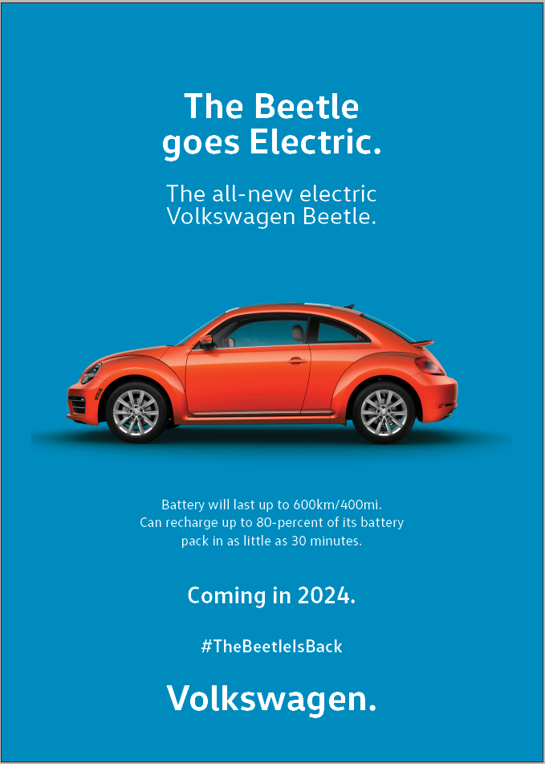
Plan for the North American International Auto Show:
- Along with the actual car, have several Beetle virtual reality simulators where people can “test drive” without leaving the building.
- Have 20 specialists to help answer queries and promote the brand on a one-to-one level, with another 4 or 5 conversing with those who prefer via text.
- Sell cupcakes w new VW logo on top; give profits to local Detroit-area food banks.

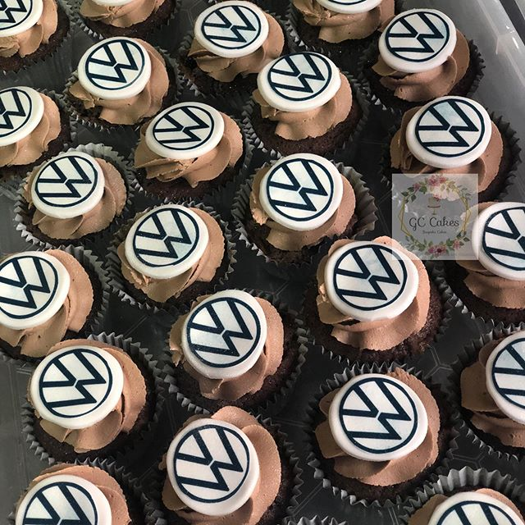
_____________________________________________________________________________________
Mock-ups for social media campaign:
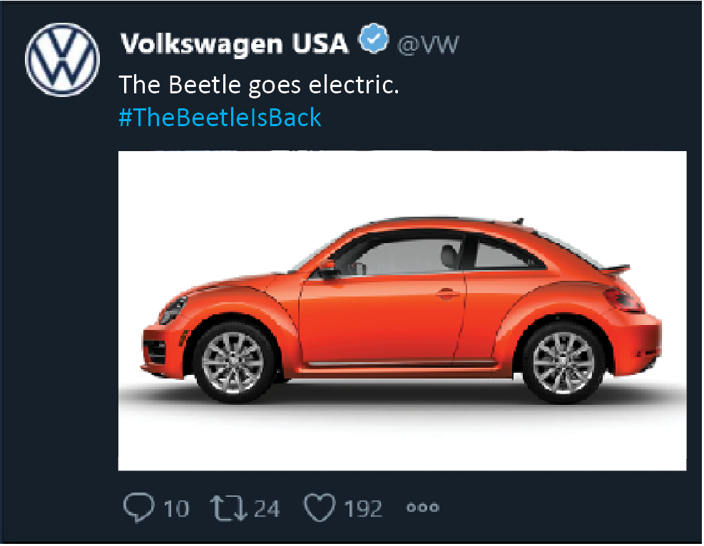
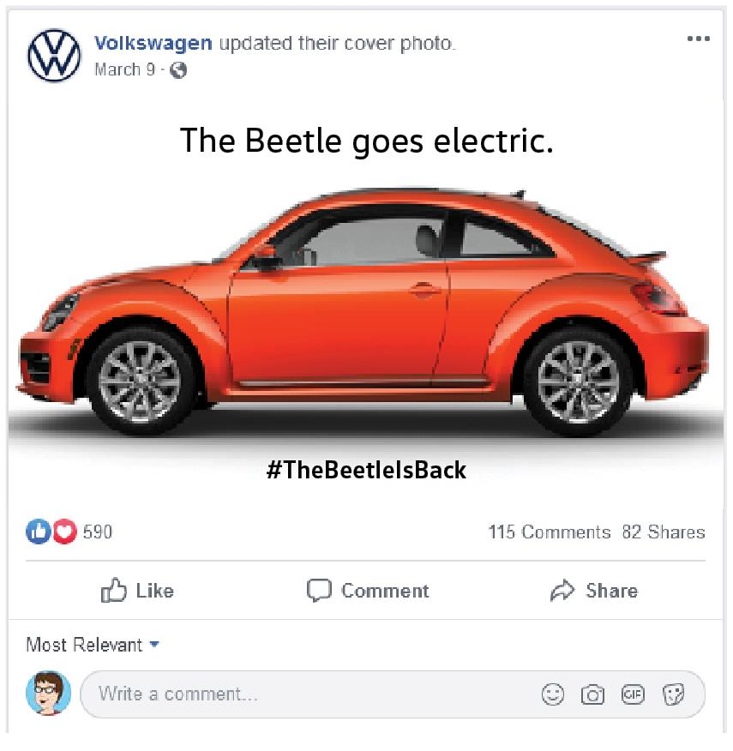

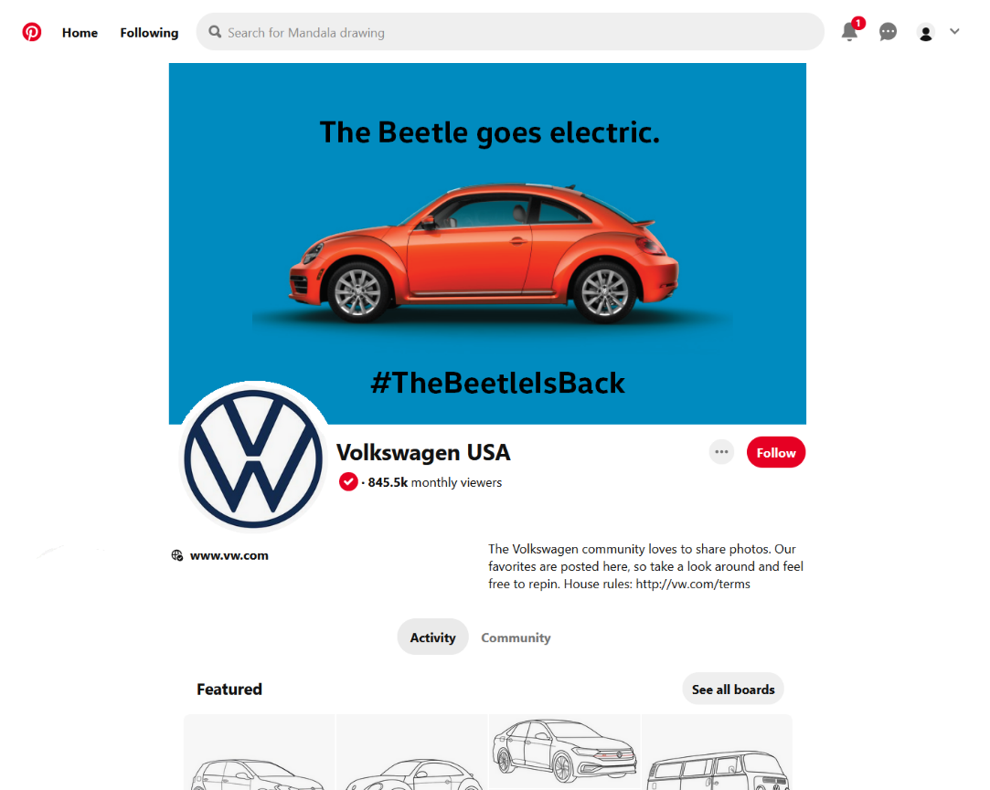

Backgrounder
The Beetle Goes Electric: The All-New All-Electric Beetle
Volkswagen Group
In recent years, automaker Volkswagen admitted to installing software that would cause cars to deceptively report lower carbon emissions. The Environmental Protection Agency (EPA) found, that in fact, the Clean Air Act was violated. Volkswagen has since recalled almost 482,000 cars and paid over $25 billion in fines and other settlements. Volkswagen has since stopped selling diesel cars in the United States. Over the next five years, Volkswagen is planning to manufacture and release all-electric versions of over 30 of our currently produced models. While Volkswagen has produced many popular models, the most beloved is the Volkswagen Beetle. Introducing an all-new, all-electric version of the Beetle will help encourage people to switch from gasoline-powered vehicles to the more environmentally-friendly electric models.
What You Need To Know About The New Beetle
The electric version of the Beetle will use the MEB (Modular Electric Model) platform, a dedicated EV chassis that will form the backbone of Volkswagen's electrification effort. Approximately 10 million vehicles will be built on the MEB architecture. Other important things to know about the new Beetle are:

- Battery Range: 200km/124.3mi
- Battery Charge Time: Up to 80% in only 30 minutes
- Acceleration Rate: 50kmh/31mph in 4 seconds
- Top Speed: 150kmh/93mph
This is all part of Volkswagen’s “E-Mobility For all” campaign. The goal is to make electric vehicles more affordable, and more appealing as batteries gain in range and fast-charging capabilities.
Out of the Past, Into the Future
Volkswagen will be investing approximately 33 billion euros in electric mobility across all models in the coming years. CO₂ emission levels per vehicle produced were already reduced by 22 percent in 2019 compared to levels in 2015. By 2025, emissions are expected to be halved. Volkswagen wants to bring the CO₂ emissions of its fleet to zero by 2050.
The Volkswagen Beetle was one of the most iconic cars of the 20th Century. Volkswagen is bringing it into the present with an all-electric version. But the battery is not the only thing that’s all-new about it. Volkswagen is relaunching its Car-Net® program with new technology and a new approach. Most of its features will be standard with the purchase of most 2024 model year vehicles for the first five years of ownership. The version that will be installed can allow for future upgrades, including voice commands. And with Car-Net, 2024 Volkswagen models will have available Wi-Fi capacity. “In the future, the automobile will be the most complex, most valuable internet device suitable for the masses,” said Volkswagen Group CEO Herbert Diess.

About Volkswagen Group
Founded in 1955, Volkswagen USA is a wholly-owned subsidiary of Volkswagen AG, one of the world’s leading automobile manufacturers and is the largest carmaker in Europe. Volkswagen is known for manufacturing efficient, reliable yet affordable vehicles.
“Volkswagen”, all model names and the Volkswagen logo are registered trademarks of Volkswagen AG.
FOR MORE INFORMATION _____________________________________________
Contact: wendy k. rasmussen, VW USA
Phone: (703) 555-5555
Email: wendykrasmussen@vwusa.com

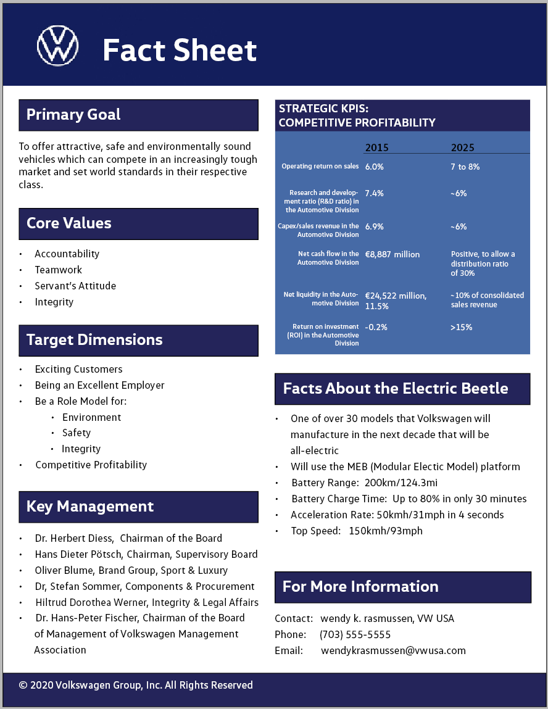
____________________________________________________________________________________

To: VW Owners, Dealers and Employees
From: Volkswagen
Subject: The Beetle is Back! And it has gone electric!

The Beetle was one of the most iconic cars of the 20th Century. Many people spent their youth with the Bug. And now, Volkswagen is bringing it into the now with an environmentally-friendly all-electric version. The Bug you love is back!
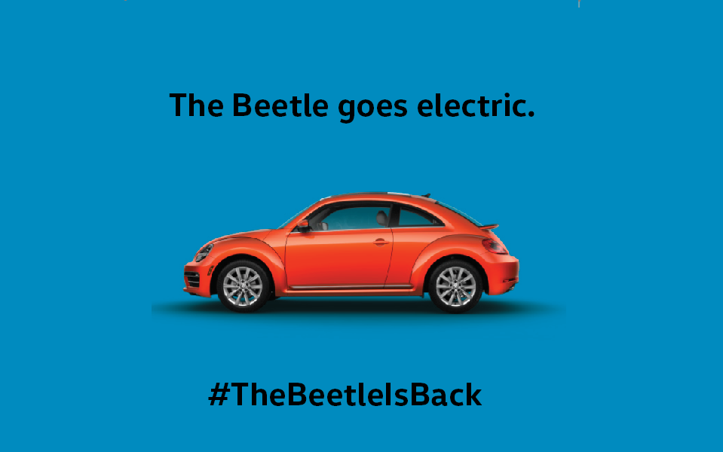
Electric cars are getting better, with farther ranges and longer battery life. The new Beetle’s battery range is 200km/124.3mi. Its charge time? Takes only about 30 minutes to get the battery to 80%! It can go from 0-50kmh/31mph in only 4 seconds! And it can get up to 150kmh/93mph! Electric cars are becoming more affordable as well. The electric vehicles that are coming from VW will be thousands of dollars cheaper than what Tesla offers right now.
The Beetle is still one of the most beloved cars out there. People simply love their Bugs. “It is a relationship you either understand or you don’t. It is the love of the bug that transcends all ages and groups,” current VW owner Heather Swanepoel told (London’s) Daily News. “There’s no better feeling than driving along and getting smiles and looks driving the Bug!”
Unlike Beetles of the past, the all-new version of the Beetle will have the latest gadgets that any geek will love: a rear-view camera system, Bluetooth and Wi-Fi capabilities, and also driver assistance features. But as always, the Beetle will have a fun, functional interior and a style like no other.
MSRP should be $32,000. But it will be lower if the electric vehicle federal tax credit is utilized.
Would you like to be the first to know when your local dealer has the all-new all-electric Beetle in stock?
Sign up here!
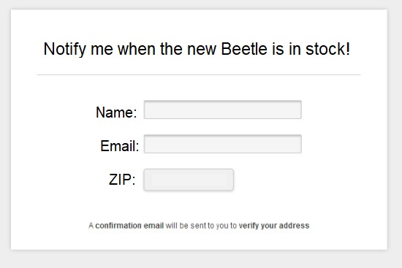

Budget:
Objectives

- To promote the new all-electric Beetle via traditional advertising and social media
- To launch the new Beetle at the North American International Auto Show in Detroit, Mich.
- To raise awareness of Volkswagen’s efforts to atone for the emissions scandal

Target Publics
The media
The community at large
Current/former VW owners, especially Beetle owners
The EPA and other pertinent regulatory agencies
Environmental groups
VW dealers and all other VW employees
Press Release Costs
News release distribution via eReleases x 3: $1,000
Compensation to writer of the press releases: $4,500
Beetle Promotion: Advertising Costs
Full page ads in Car and Driver and Motor Trend: $250,000
Full page ads in Hot Rod, Road and Track, and Automobile Magazine: $350,000
Cost to post on Facebook, Twitter, Instagram and Pinterest: $0
NAIAS costs
Payroll cost for specialists working at NAIAS: $30,000
Space rental at NAIAS (1000 sq ft): $150,000
Rental costs for 3 90-inch monitors for 14 days: $55,000
Costs of creating, constructing, running and dismantling booth at NAIAS:
Booth design (w video monitors, etc). $1,000,000
Carpenter costs: $4.000 (4 workers @ $100/hour for 40 hours each)
Rigging costs: $14,400 (4 workers @ $90/hour for 40 hours each
Electrician costs: $15,200 (4 workers @ $95/hour for 40 hours each)
Forklift operators: $16,800 (2 workers @ $210/hour for 40 hours each)
Shipping/drayage costs: $3,400 (2 workers @ $85/hr for 20 hours) to ship to and back to storage warehouse; $4,000 (40 hours worth at $100/hour) to ship to and from TCF Center
Banner space (on the outside of TCF Center): $100,000
Cost of local advertising (both TV and digital): $100,000
Cost of 3 virtual reality simulators: $1,200,000
Cost of various kinds of VW gear to sell at NAIAS: $30,000
Cost of tri-fold brochures to hand out: $500
Cost of 1000 cupcakes: $3,500
Cost of vacuuming the booth floor daily, for 14 days: $2,240
Internet access @ NAIAS: $2,640 (2MBps)
Liability insurance: $400
Miscellaneous
Unexpected expenses: $100,000
Total costs: $3,337,580
Evaluation of the Public Relations Campaign
The campaign will be considered a success when over 100 news outlets that reach the general public and 80% of the major automotive news outlets publish press pieces about the new Beetle, the Beetle retrofit program and/or the announcement of the oversight committee in the next 3 months. The campaign will be a success when 50 of those 100 news outlets have a circulation of 100,000 or more. The campaign will be a success when those news outlets utilize the main information and talking points that we have provided, and frame it in a generally positive light.
The campaign will be a success when VW.com has 15% more visitors, and 25% more on pages related to the Beetle in the next 3 months, as measured by Google Analytics.
The campaign will be a success when 5% of VW.com visitors sign up for updates in the next 3 months, as measured by Google Analytics. It will also be a success if in the next 3 months 10% of all e-newsletter subscribers sign up to be notified when the new Beetle arrives, again, as measured by Google Analytics. Customers who visit VW dealerships, again, in the next 3 months, will be asked if the buzz about the new Beetle or the other issues of the campaign were a factor in their decision to come in.
Focus groups, made up of both of members of the general public and separately current/former VW owners in several different areas of the country, will be conducted before the campaign to determine awareness of and loyalty to the Beetle brand, and to seek their opinions of Volkswagen regarding the emissions scandal. Enthusiasm for the idea of an electric Beetle will be analyzed to determine how many VW should manufacture at first. Here are some possible questions the VW owner groups could be asked:
- What is the first thing you think of when you hear the name Volkswagen?
- What do you like best about Volkswagen? What do you like least?
- Are you happy owning a Volkswagen?
- What is your opinion of the VW Beetle? Would you consider buying an all-electric one?
- How likely are you to buy an all-electric Beetle or other Volkswagen?
- How likely are you to buy a vehicle from another automaker?
- Is cost a factor when making this decision?
- Do you trust Volkswagen to do the right thing?
- How likely are you to recommend Volkswagen to others, including loved ones?
Those same focus groups will be assembled again the 3 months after NAIAS to determine what, if anything, has changed in their opinions. Online surveys via our social media accounts can also be utilized. However, such polls are not scientific and can be skewed negatively by bad actors. But it still may give us some insight as to what the general public is thinking.
The campaign will be considered a success when VW mentions in general on social media go up 15% and the mentions in general are positive, and also when the hashtag #TheBeetleIsBack is used over 10,000 times on Facebook, Twitter, Instagram and Pinterest combined. Each platform has their own analytics function that can be accessed.

