wendy k. rasmussen
MKTC 2515 Digital SEM and Analytics
Semester Project, Part One
January 21, 2020

(i’m STILL not sure if I need to write anything in addition to submitting these screenshots…)

Screenshots from KW Finder:
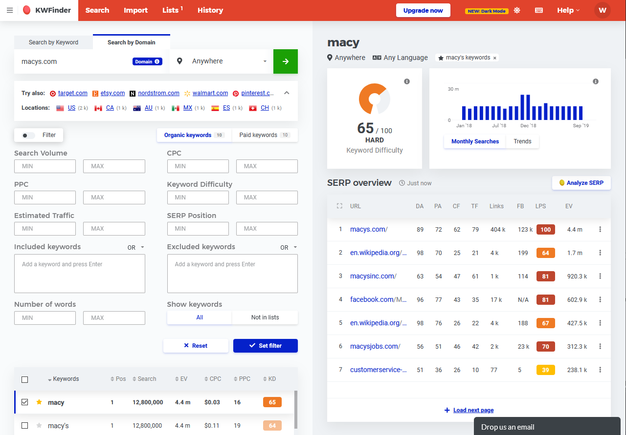
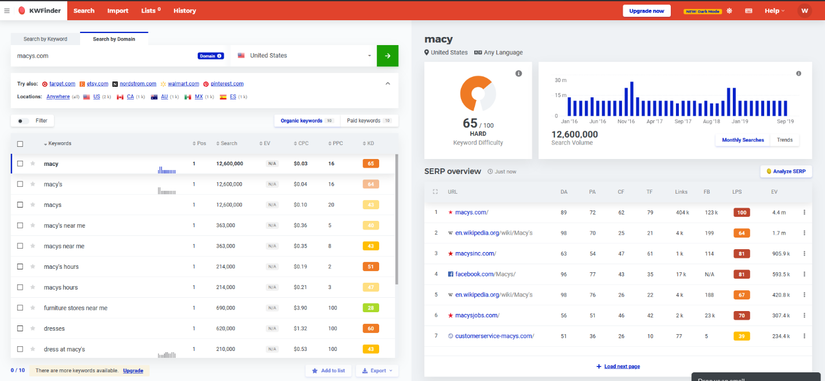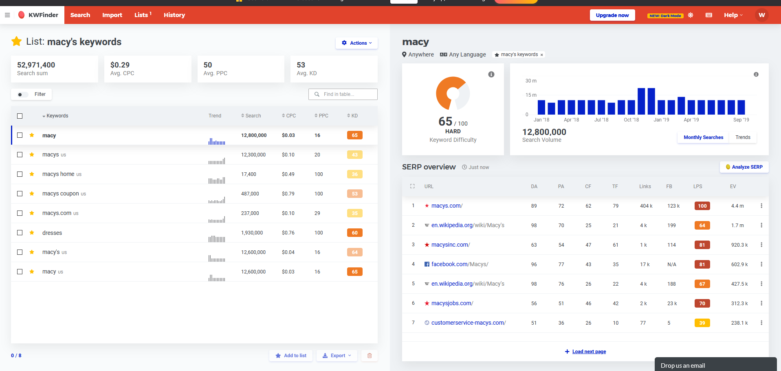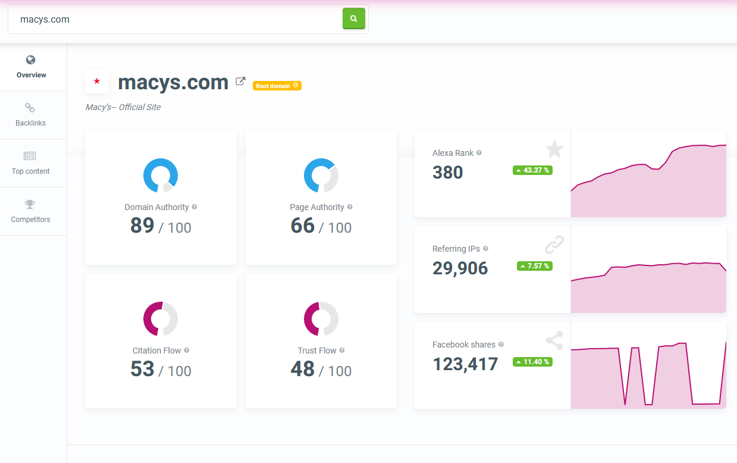
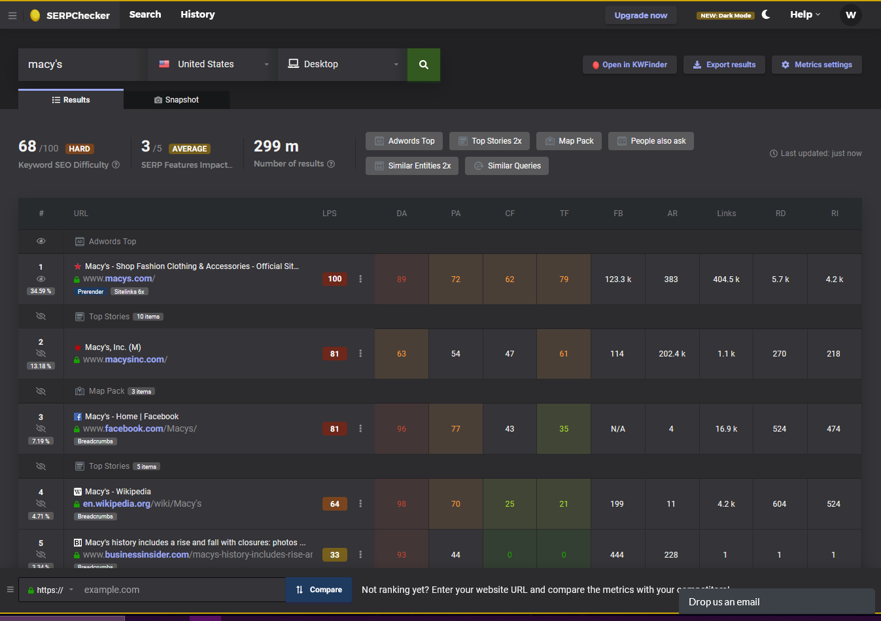
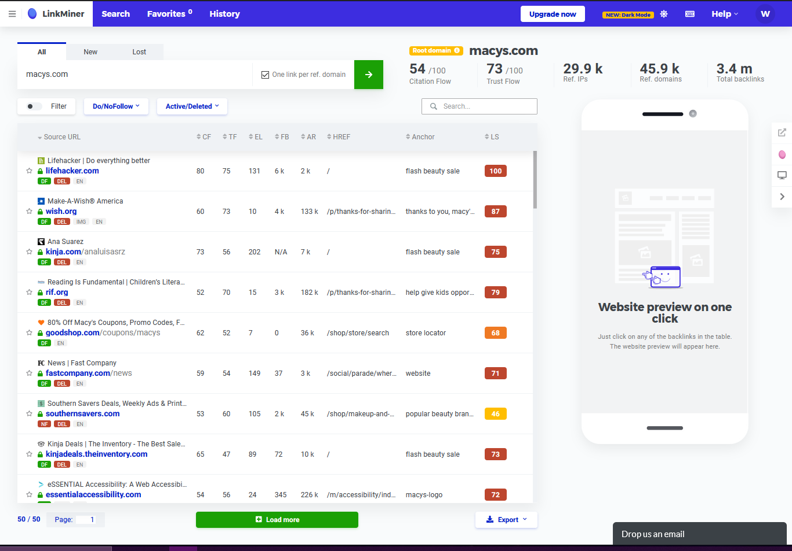
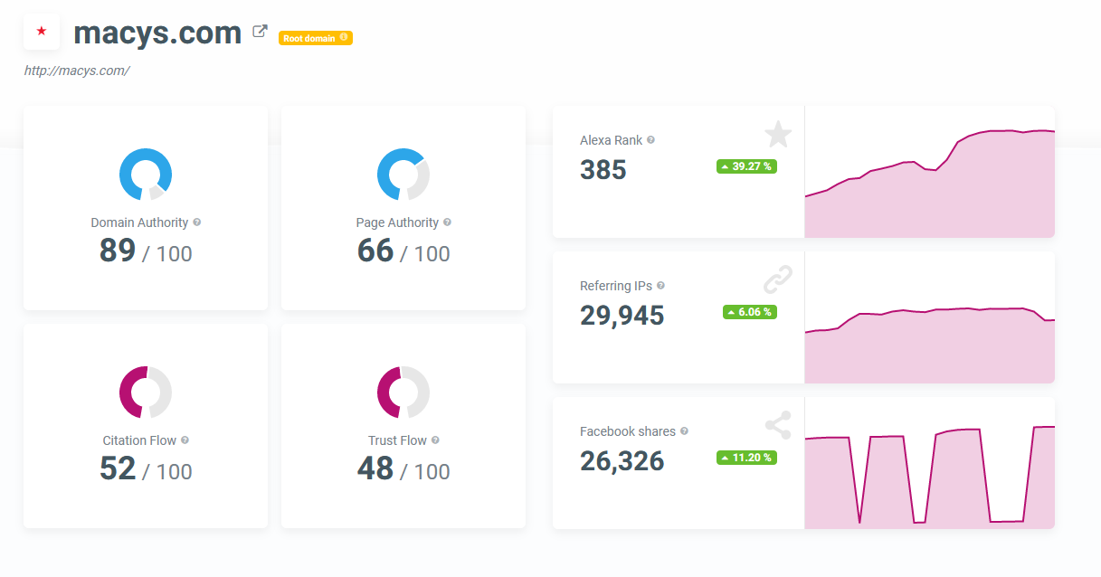
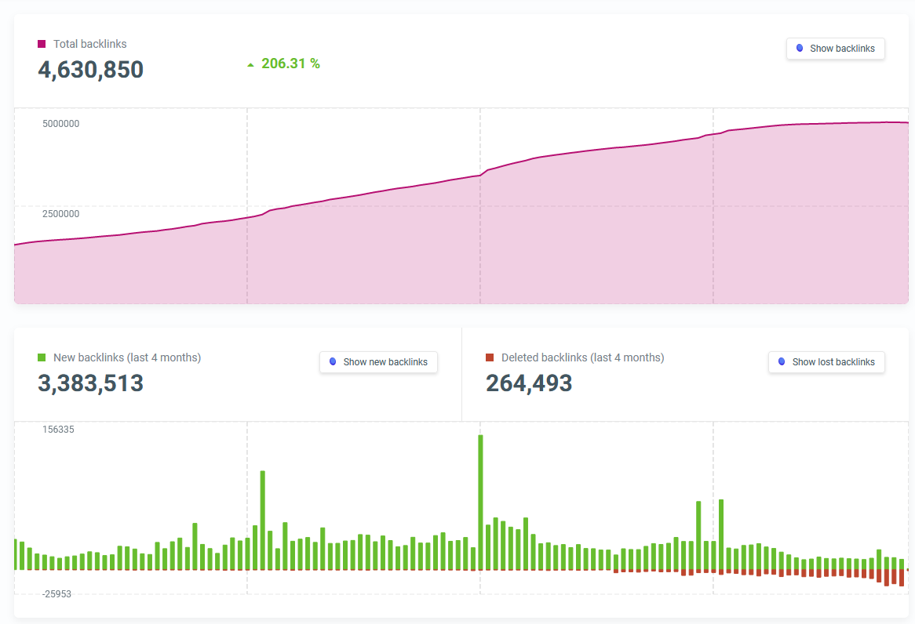
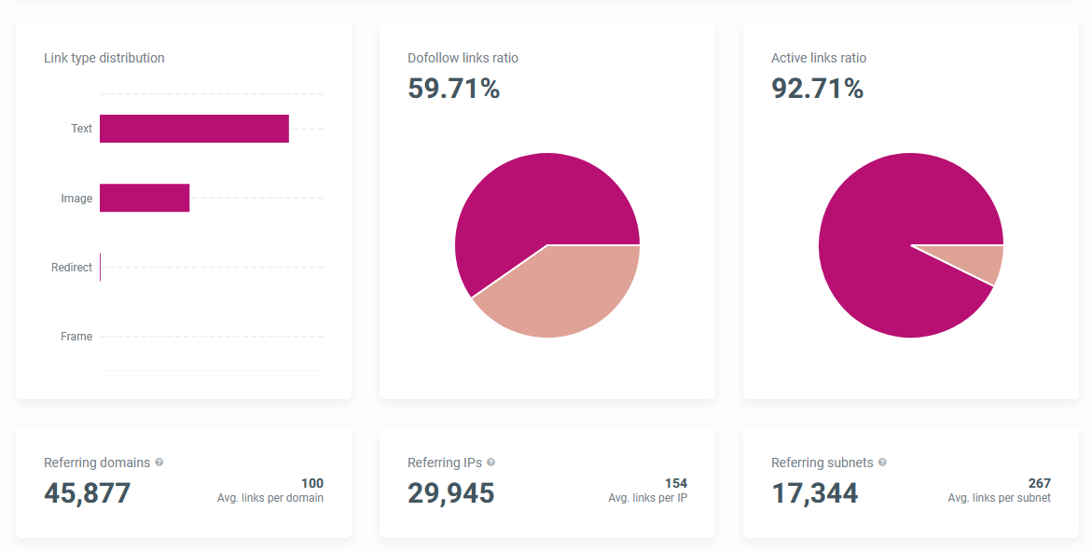
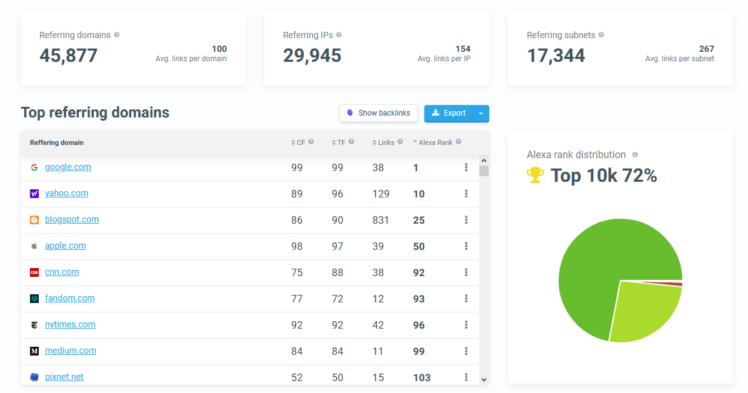
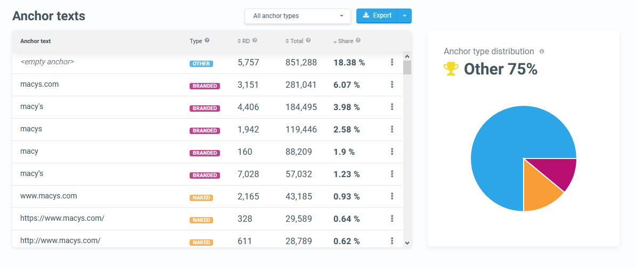
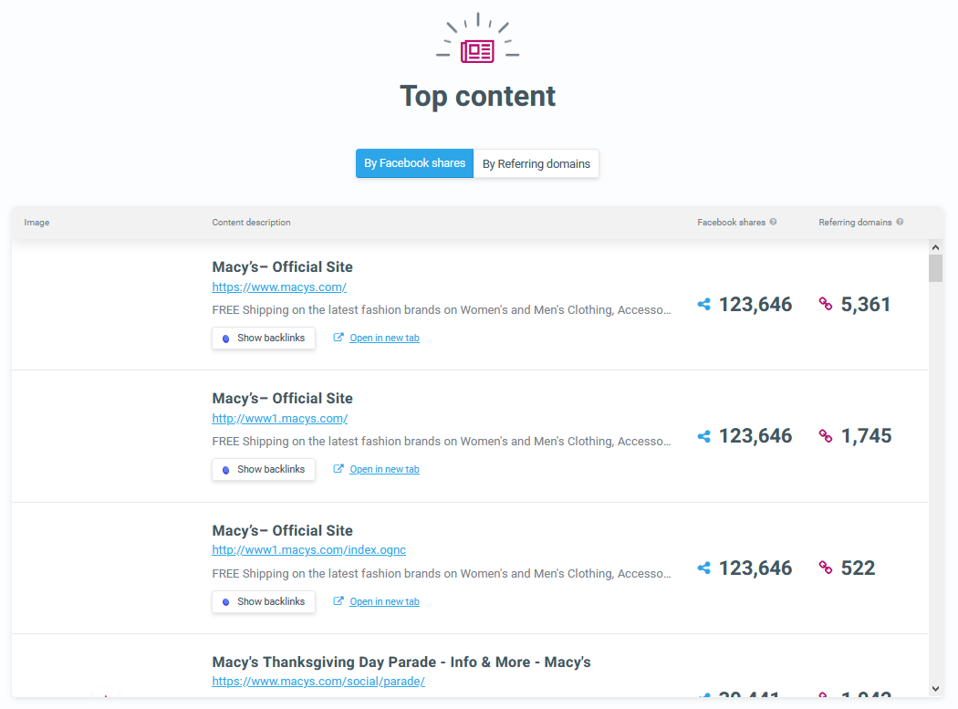
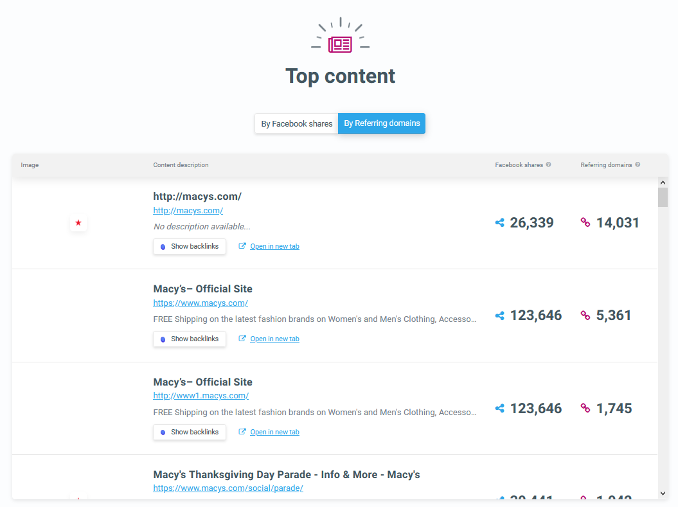
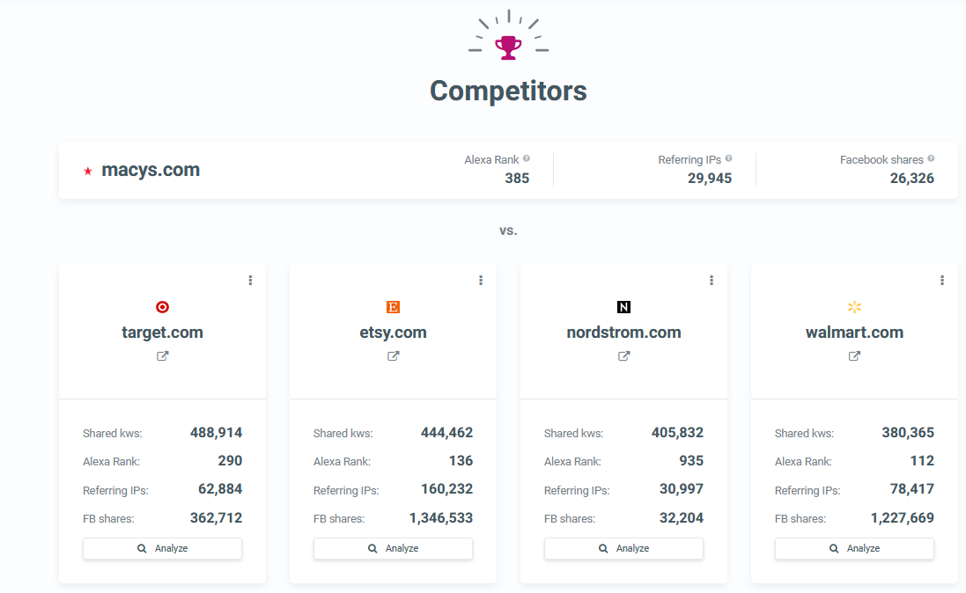
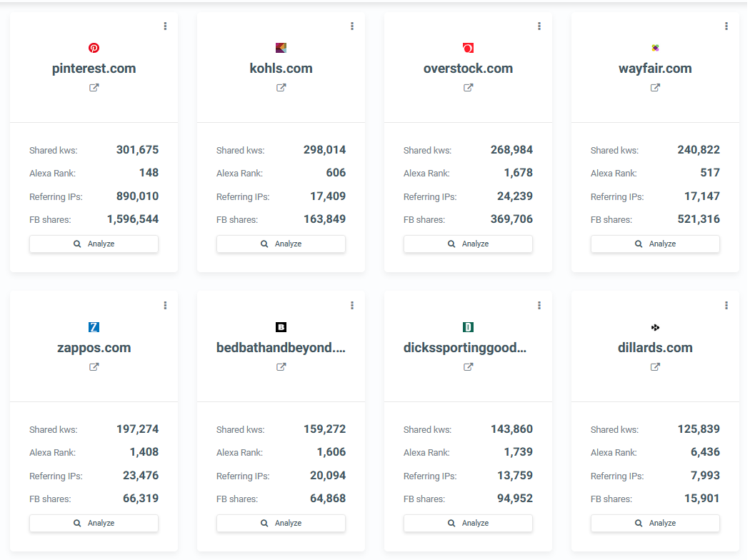
Screenshots from Alexa.com:
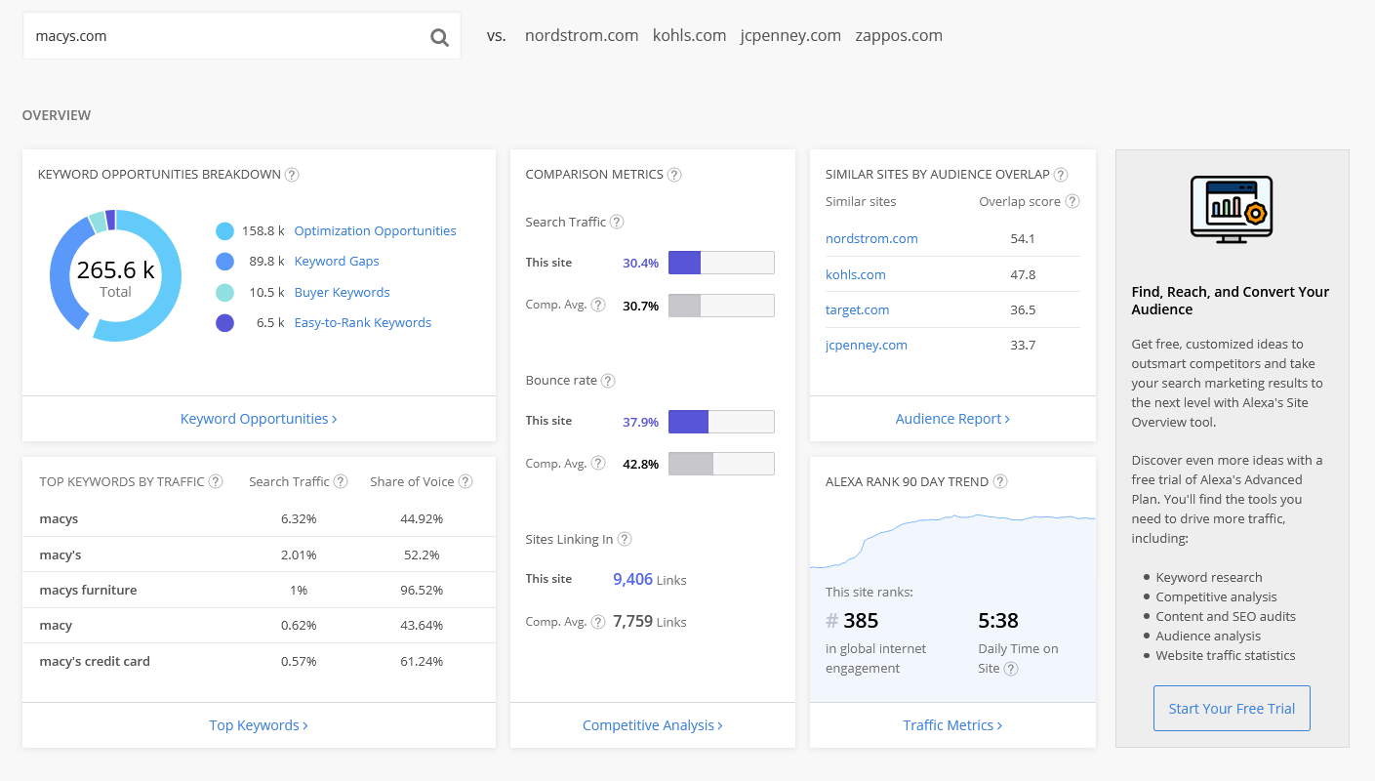
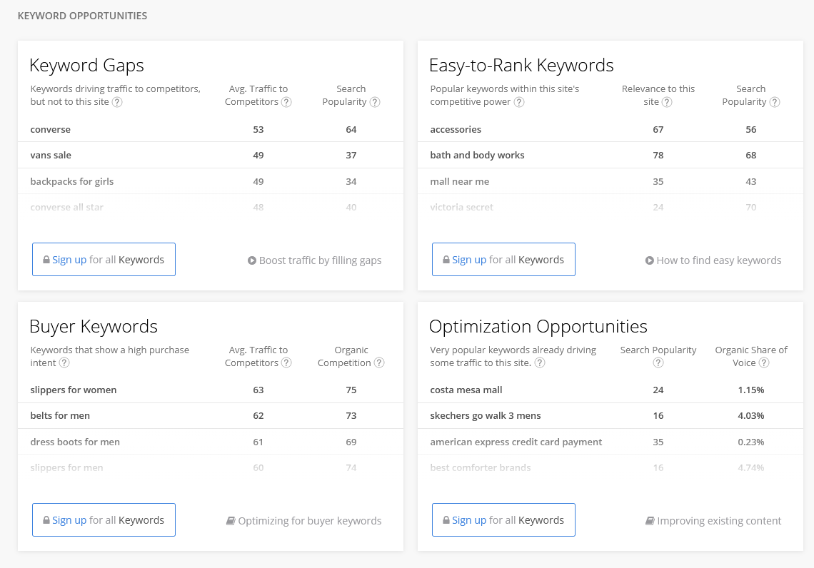
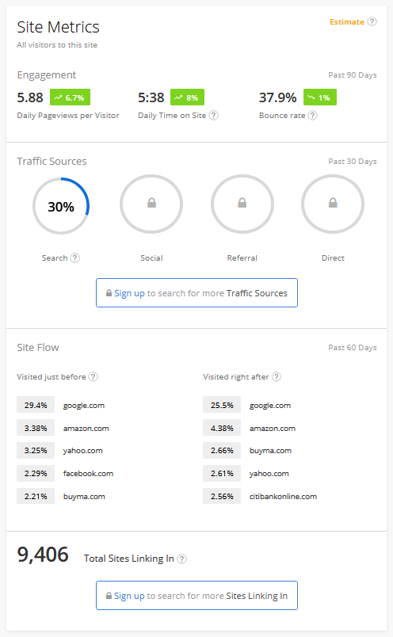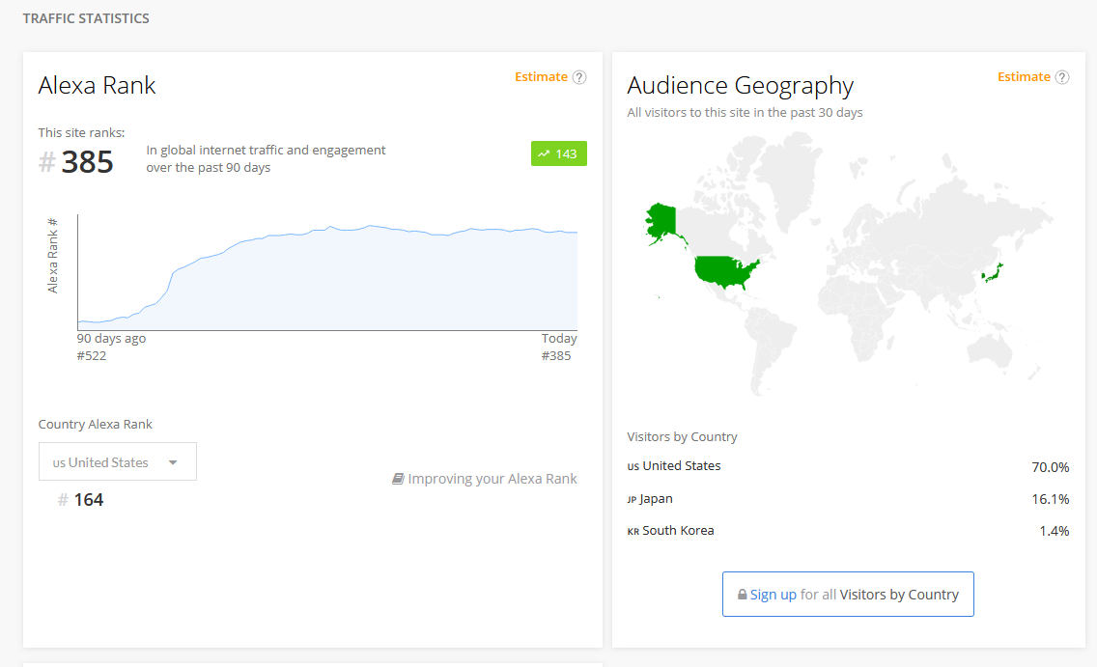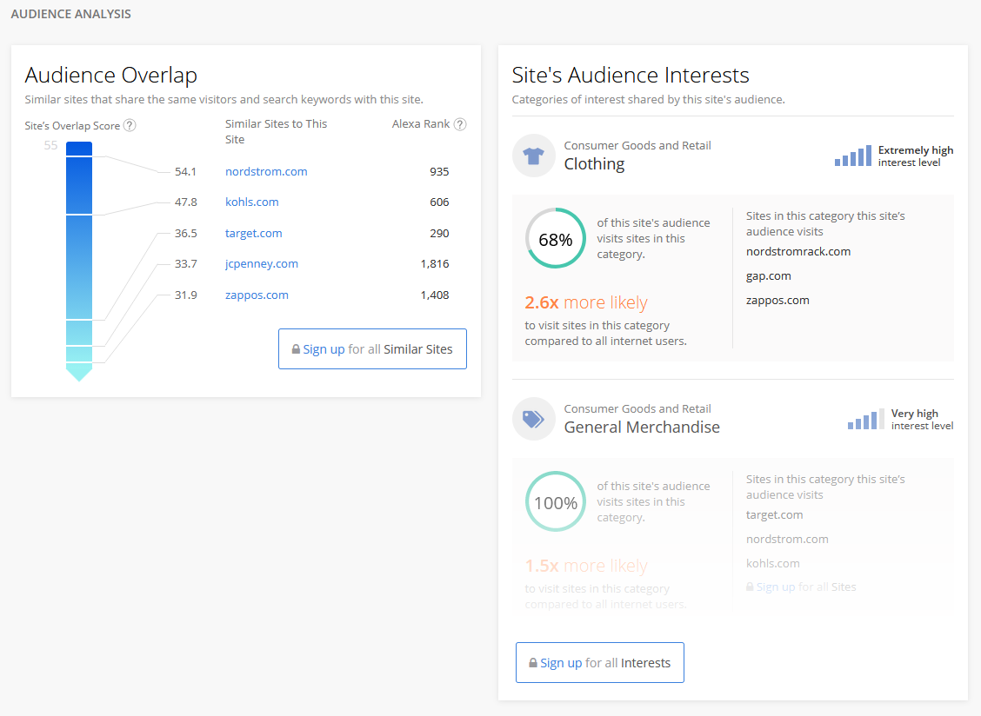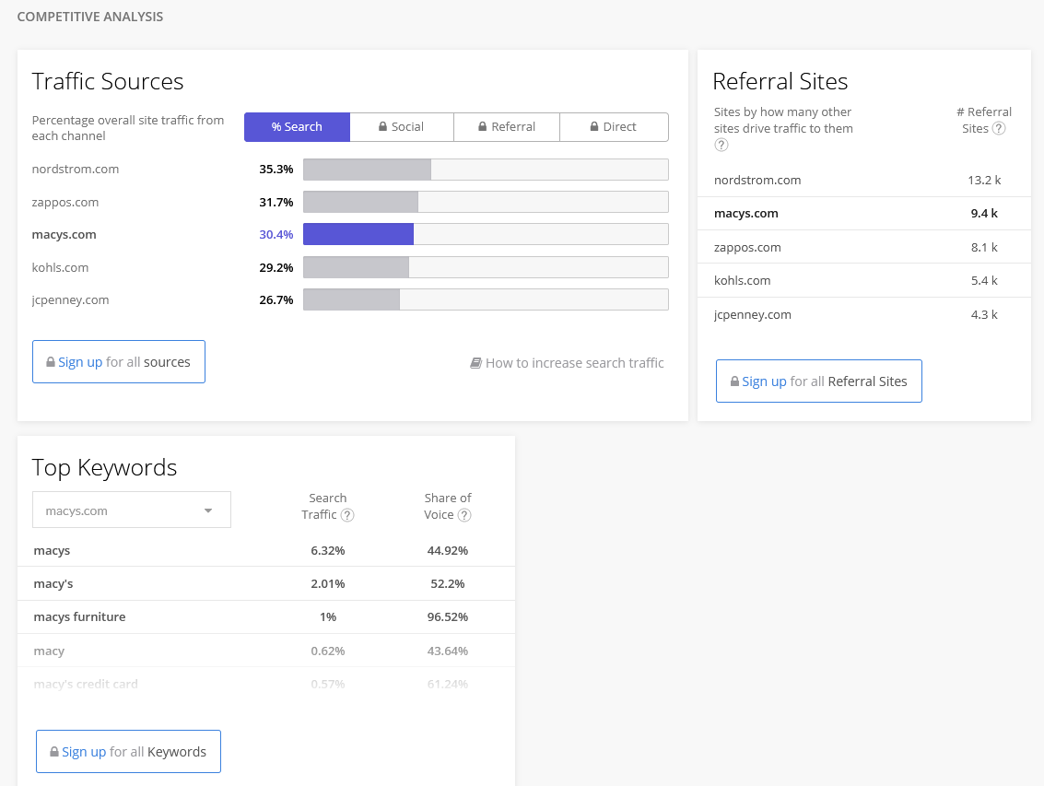
Screenshot from backlinks.com
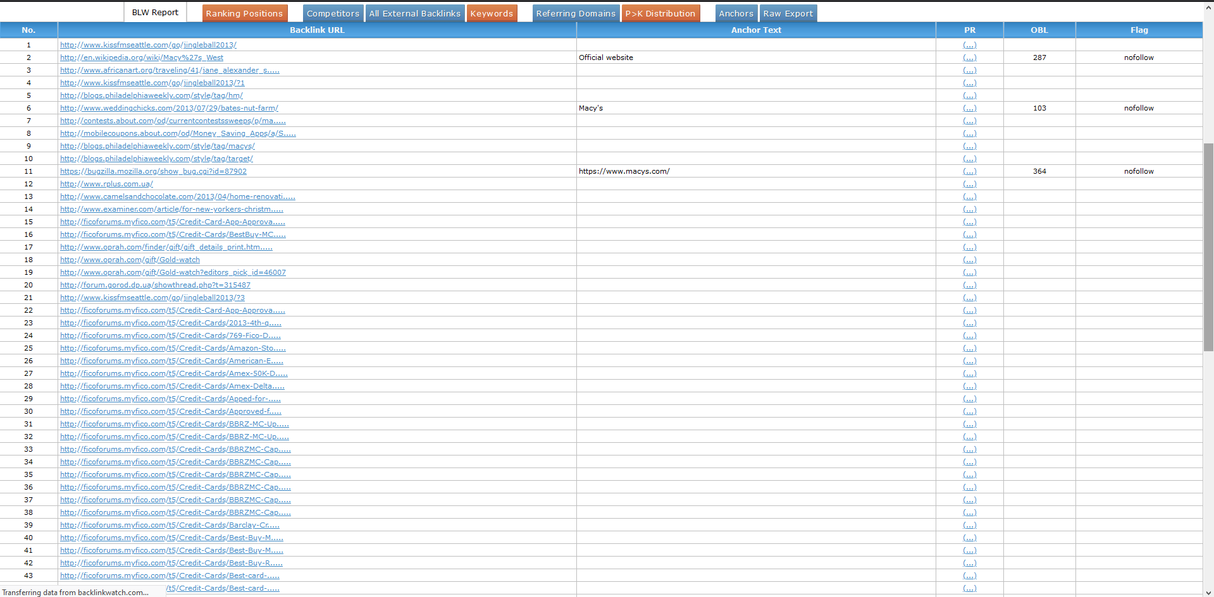

Screenshot from LinkMiner:
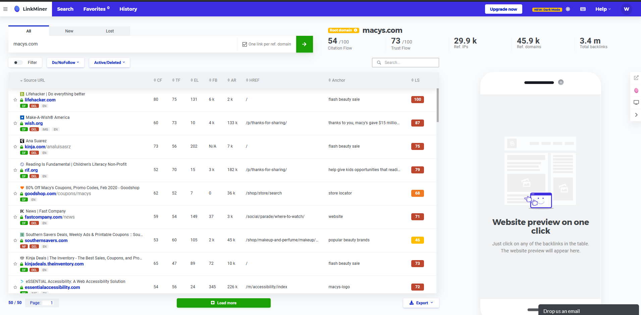
Screenshots from moz.com:
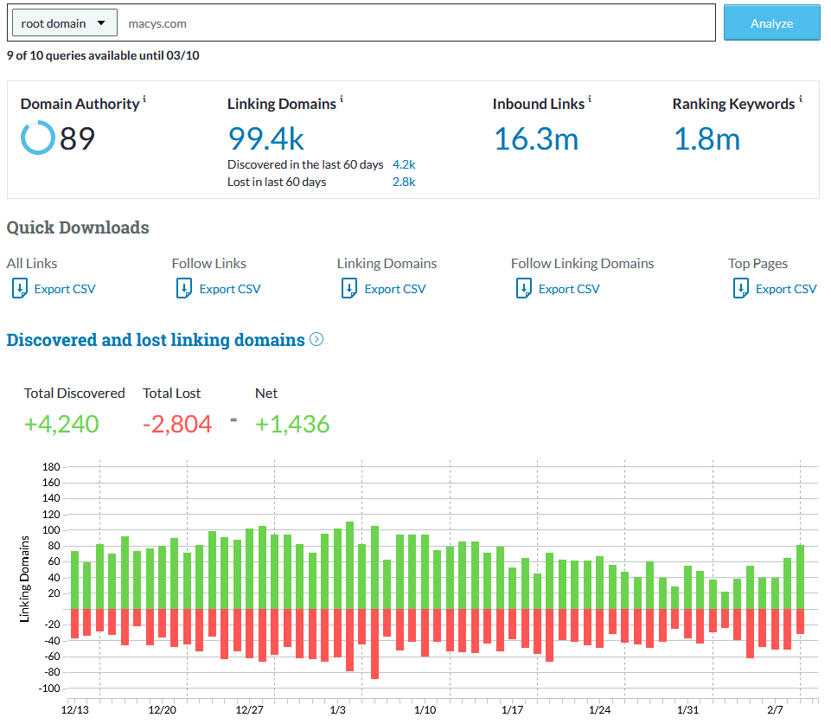
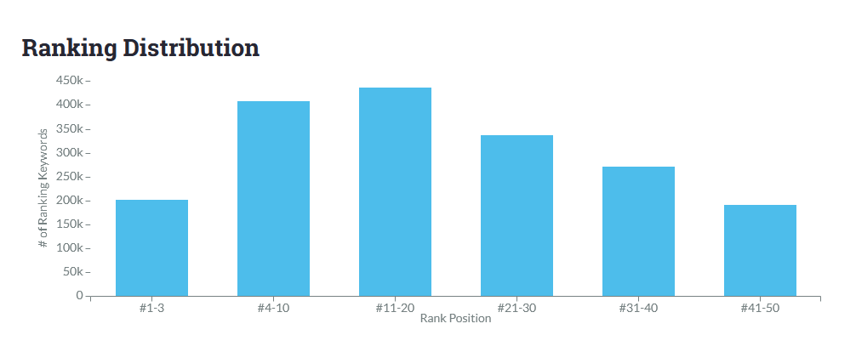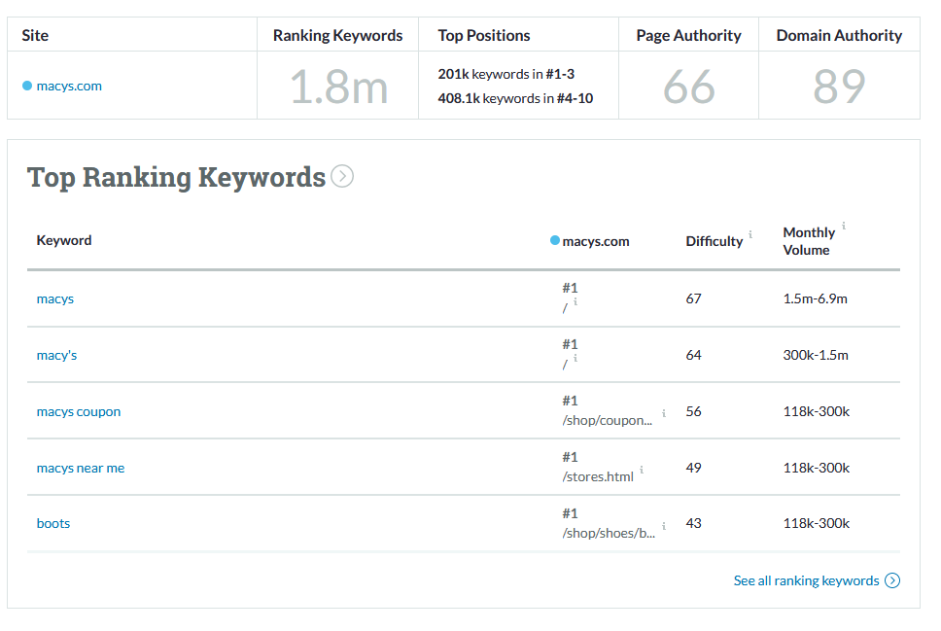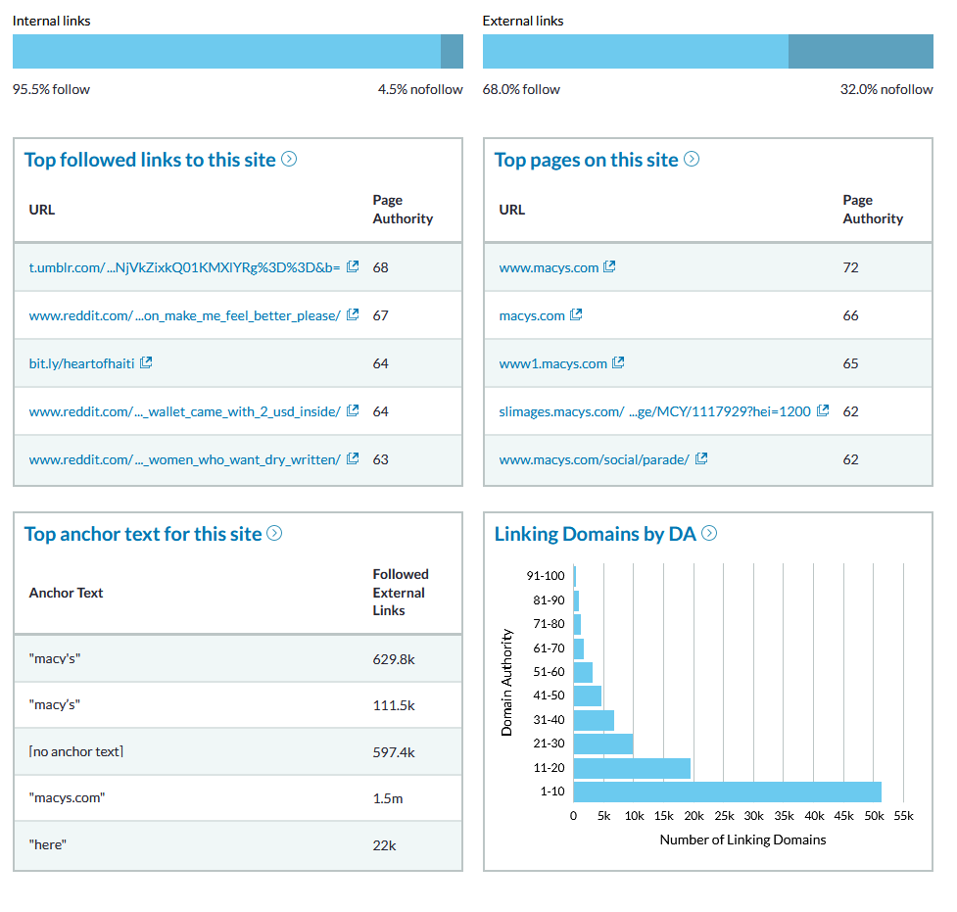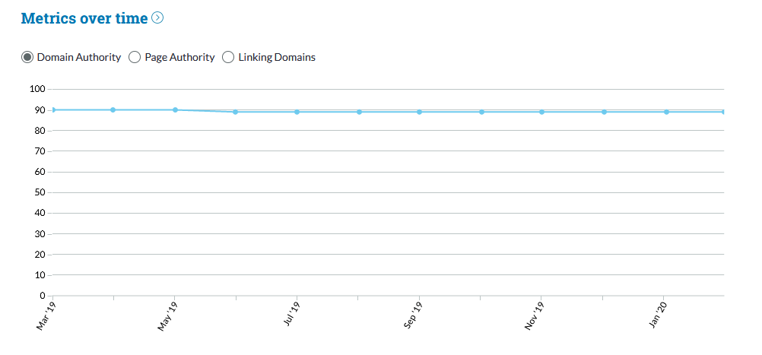

SER screenshots:
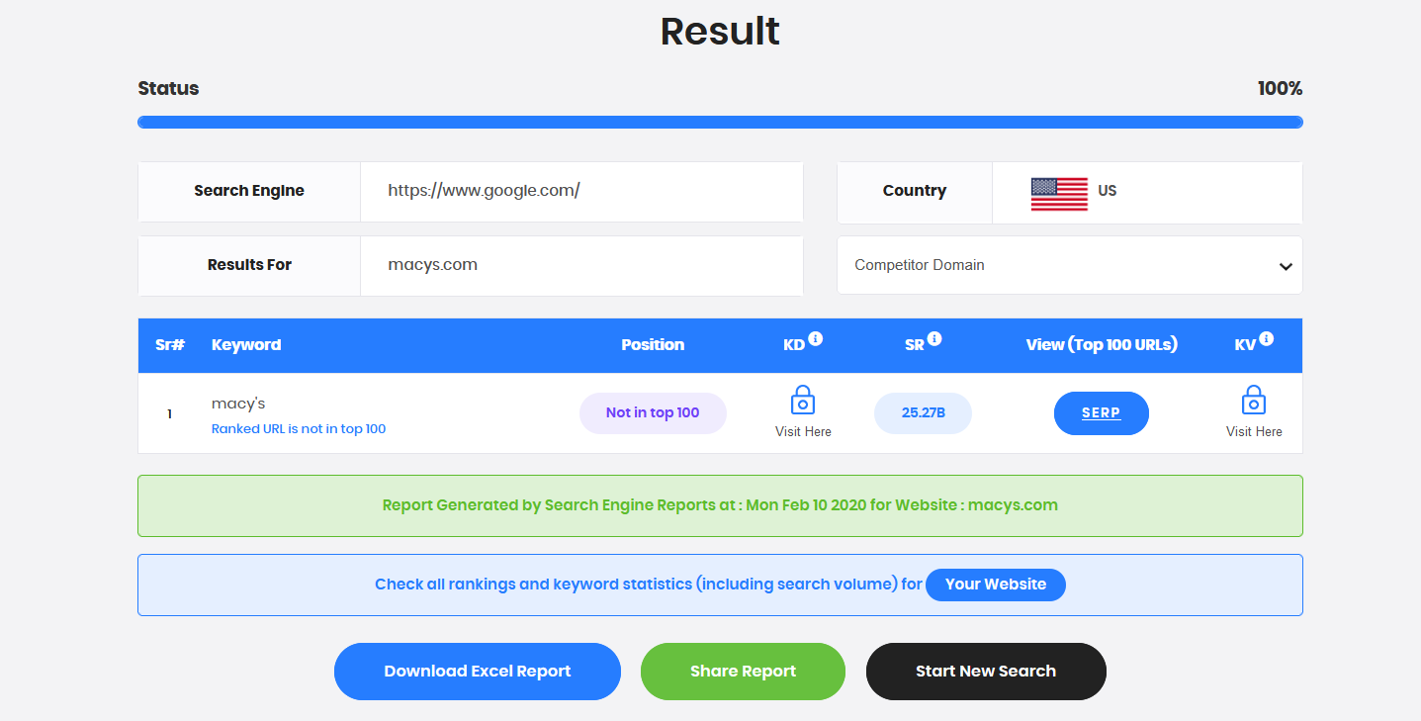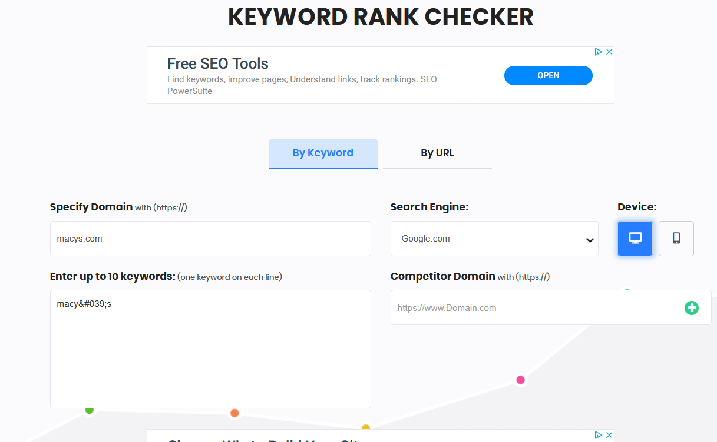

(I cannot claim Macy’s for Google My Business and I don’t have another organization in which to build an account with.)
Five things that i learned about using Google My Business for one’s organization:
- Make sure your business is not already on Google; duplicate listings will only cause problems.
- Choosing the most accurate business category is essential to your business being successful on Google.
- The more complete your listing is, the easier you will be found on Google.
- Be selective in which secondary business categories you use. Keep it simple.
- Keep keywords, links and hashtags out of your business description. The description does not factor into Google rankings.
Topic Ideas for a Blog
- Promo piece about Market By Macy’s.
- Promo piece for The Workshop at Macy’s Business Development Program for Women and Minority Owned Businesses.
- Intro the new Danielle Bernstein line.
- How Macy’s is handling the COVID-19 pandemic.
- Announcement of 2019 Q4 earnings.
- Announcement of new Polaris Strategy.

Blog keywords
- Macy’s
- Person of color
- Women
- LGBT
- Veteran
- Workshop
- Program
- Business

Macy’s Offers Workshop to Develop High Potential Diverse Businesses
Are you a woman, a veteran, an LGBT person and/or person of color who wants to grow your business? Then you need to know about The Workshop at Macy’s! If you qualify, Macy’s will give you the tools you will need for success and growth in the retail industry. Now in its tenth year, more than 100 businesses have benefitted from this workshop. Some even go on to have their merchandise sold at Macy’s or other large retailers!
Macy’s CEO Jeff Genette:
“Our vendor relationships are an important aspect of our diversity and inclusion strategy. We are working to support the next generation of diverse suppliers by ensuring they are integrated into our merchandising and business development strategies. Our Supplier Diversity Program is designed to connect more ethnically diverse-, women-, veteran- and LGBTQ-owned businesses to opportunities within Macy’s, Inc., enabling us to have more distinctive merchandise, contribute to the economic health of local communities, and help grow the number of diverse suppliers in the retail industry.”
Macy’s is always looking for new ways to innovate and Is committed to the development of vendor resources. Macy’s, Inc. sells iconic brands under their worldwide known subsidiaries: Macy’s, Macy’s Backstage, Market by Macy’s, STORY, Bloomingdale’s, and Bluemercury. They currently operate 551 stores and the following websites: www.macys.com, bloomingdales.com and bluemercury.com.
To qualify for the workshop, you must:
- Be a woman, or a veteran, LGBT, or of Black, Hispanic, Asian-Indian/Asian-Pacific or of Native American heritage
- Be a U.S. citizen or have permanent legal resident status (note: you must provide proof of your status)
- Have a U.S.-based business that produces goods suitable for a department store environment
- Have the ability to travel to New York City to attend the workshop.
- Be age 21 years or older
Once accepted for the program, you will learn and then do the following:
- Present your product line to merchants who will determine the viability of doing business with you
- Understand retail industry practices, what merchants need and measurements of success
- Analyze business opportunities and threats to establishing a strong relationship
- Reconstruct your business’s operations and calibrate them to better maximize sales and profits.
- Learn how to build a powerful brand strategy
- Develop and present a strategic plan
- Understand math basics in the retail environment
Being in this FREE program will give you an exceptional opportunity to develop your business skills and capacity to potentially partner with a major retailer. One graduate of the workshop has this to say:
“The whole program has changed my life and my business. The information that I received is of so much value. Everything within my business will be revisited. The access of the tools…definitely change the decision making process. The value that I can give to my team in order to grow is a wonderful gift. My business is ready for growth. What was needed I received it during the week of the Workshop. The access to the people who saw my product and the opportunities that I have moving forward is more than I can ask.”
There are two ways to apply for The Workshop at Macy’s: you can submit your entry via our online application, or you can mail in your entry (Download mail-in application), The deadline for the 2020 class is 11:59PM ET on January 26, 2020.

