wendy k. rasmussen
MKTC 2506 – 59 Digital Marketing
Semester Project
Fall 2020

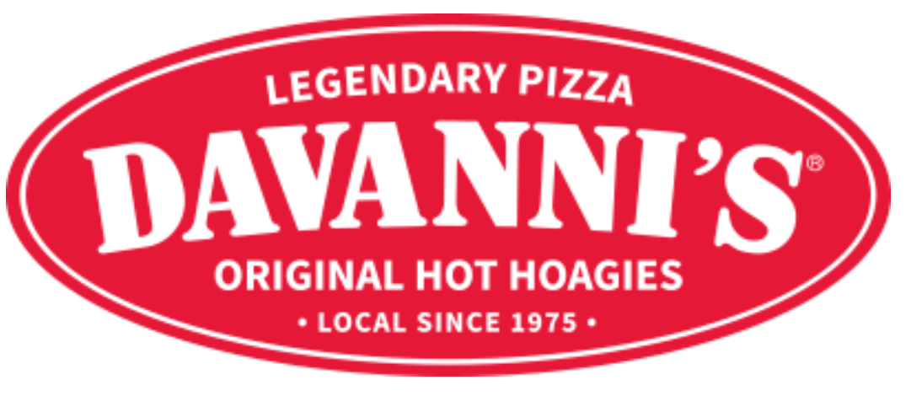

DIGITAL MARKETING PLAN FOR
DAVANNI’S PIZZA & HOT HOAGIES

BACKGROUND
Under its original name, Pontillo’s Pizzeria, Davanni’s Pizza & Hot Hoagies first opened in October of 1975. Its mission was to introduce New York-style pizza and hot hoagie sandwiches to the state of Minnesota. Davanni’s has now grown to now include 21 locations and it employs 1,100 people. They also operate Oven Hearth Bakery in Saint Paul, Minnesota and a coffee shop, Coffee Bene’, also in Saint Paul. To this day Davanni’s is a local business, privately held, and family owned. Davanni’s not only sells pizza and hoagies, they also sell pasta, calzones, salads, wings and other sides, drinks and desserts. They also sell frozen pizzas, sauces and cheese at local grocery retailers.
It has been important to Davanni’s to support the communities they serve, because the communities support them. The company’s taxes and profits are re-invested into those communities. They purchase most of their ingredients from local suppliers. They also take pride in their employees’ ability to care: about the food they make, the people they work with, and the customers they serve. In fact, it’s a job requirement. Davanni’s also cares about their customers by doing what they can to make their food as healthy as possible, with leaner meats and lower levels of sugar, shortening and salt than the competition. Finally, they help out the community by helping local groups hold fundraisers in their restaurants and they also sponsor multiple community sports teams.

THE DEMOGRAPHICS AND PSYCHOGRAPHICS OF
DAVANNI’S CUSTOMERS
Since Davanni’s is a local business, its customers mostly reside in the greater Minneapolis and Saint Paul metropolitan area. Therefore, this area will be the focus of this digital marketing plan.
In the United States, $16.5 billion was spent by consumers on takeout pizza in 2016. In 2015, most Americans consume pizza from a restaurant at least once a month; 35 percent opted to dine-in or purchase a frozen pizza and the other 65 percent chose takeout or delivery. 61 percent said that they have had pizza delivered to their homes or offices and 54 percent have opted to do takeout. COVID-19 has most likely made this balance shift as many more people opt to do curbside pickup. The majority of pizza consumers, but especially millennials and Generation Z, are more likely to order pizza through text, a smartphone app or online versus calling the shop directly.
People have pizza delivered or pick it up because of its convenience. They also order via text, via app or online due to its convenience. Those who do order online spend more than those who dine in, in part because their payment information is stored online and restaurants can customize offers to them. In fact, 50 percent of Domino’s and Papa John’s sales are through online orders. Takeout pizzas are ordered mostly by families or groups.
Millennials are a large segment of pizza consumers: particularly millennial women. 63% of pizza consumers are female, and of that group, 41 percent are millennials. They are diverse and are highly educated. Millennials are also quite health conscious and want natural and gluten-free ingredients. They also tend to resist food that they perceive as artificial or comes from a big conglomerate.
Generation X is the most likely to order pizza, they prefer it over other categories of takeout food. And even though they have less spending power, they have the highest median household income. Gen X is more likely to splurge on a night out. Also, they are usually the heads of household and have great influence over Generation Z, who is just starting to put their preferences as consumers into practice. Generation X wants comfort food and familiarity, though they are open to being somewhat adventurous, as long as there is a sense of authenticity. They want creative takes on familiarity. Gen X wants food that is fresh and preferably organic, made in-store, and will pay more to ensure that. There is a soft spot for carbonated beverages among Gen Xers, especially those that come from the fountain. The majority of Gen Xers consume alcohol; beer, cocktails and wine are most popular, in that order.
Customers of all generations want food that is functional. They want to consume food that is beneficial, in both a physical and an emotional way. They want to feel good about what they eat and drink. They don’t want to hear about what they’re missing (low-fat, low sodium, etc.), they want to know the positives.

COMPETITION AND SWOT ANALYSIS
13% of all US restaurants are pizza/pasta related. There are 95,000 pizza outlets nationwide, and Prisome of those, both national chains and local independents, compete with Davanni’s in this market. The most notable of these include:
- Domino’s
- Pizza Hut*
- Little Caesar’s
- Papa John’s
- Papa Murphy’s
- Jet
- Chanticlear
- Marco’s
- Punch
- Pizza Luce
- Blaze
- Chuck E. Cheese*
- Old Chicago
- Pizza Ranch
- Godfather’s
- Giordano’s
- CiCi’s
There are asterisks besides Pizza Hut and Chuck E. Cheese because they have recently declared bankruptcy and may soon no longer be in in business. Time will only tell if other competitors will cease operations, most likely because of COVID-19 and the resulting plunge of the economy. For now, large pizza chains are doing better than independent operators and smaller chains like Davanni’s.
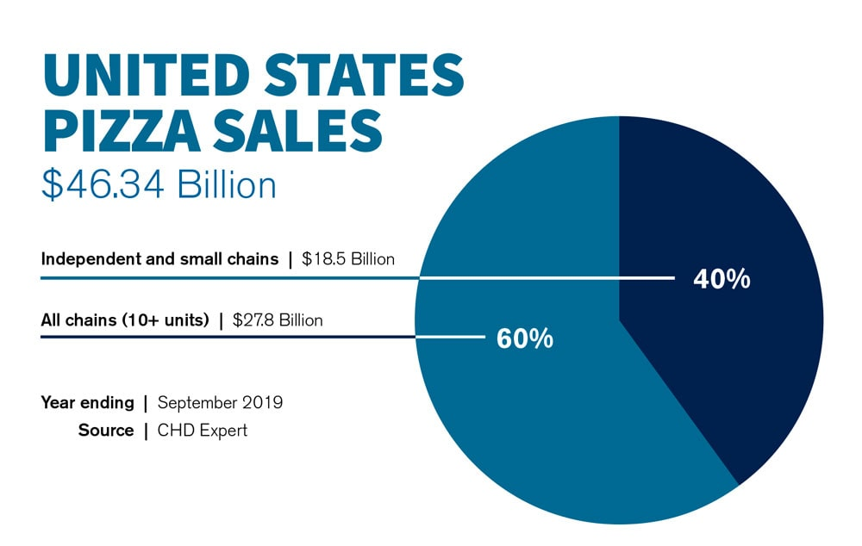

Also, the number of app-based restaurants, and “cloud kitchens”, are on the rise, especially in the wake of COVID. Third party-delivery services like DoorDash and GrubHub could be a major problem in the future as well as it comes to industry players. The restaurant business as a whole is rapidly shrinking right now, so competition is even more fierce than it has been.
The future of Davanni’s also lies in adopting new technologies, including the possibility of automated deliveries, whether it be by drone or some other form of robot. Customers think that technology should help improve customer service, make paying easier, and offer more convenience. More and more, customers say they would prefer ordering from a tablet at the table or via a self-service kiosk, even though the staff at Davanni’s is exceptional.
Although Davanni’s offers healthy options when it comes to pizza, and the majority of their ingredients are locally sourced, another opportunity for growth is by offering a wider variety of pizza toppings and even sauces, especially when it comes to increasing vegetarian and even vegan options. Offering plant-based protein toppings is likely the inevitable option. The same goes with alternative forms of crust, such as cauliflower. Gluten-free options should be increased. People, mainly younger ones, want new flavors and spicy options and they will not come back if they don’t get them. The trend these days is also towards grab-and-go; this should be expanded on. Another opportunity would be to sell individual slices at all times of the day instead of just at lunch. People who want pizza for dinner or a late night snack should not have to commit to buying an entire pie if they live alone. Producing frozen solo-sized pizzas to be sold in grocery outlets is another option.
Davanni’s will need to increase both speed and convenience, and it will also need to offer more options that appeal to more customers in order to if not grow, at least survive.
OBJECTIVES AND STRATEGIES
The main objective is simply for Davanni’s Pizza & Hot Hoagies to survive the COVID-19 pandemic. Sadly, for many restaurants, the pandemic has caused them to shut down, or at least severely curtail their activities. Even larger chains are not immune to this reality. Davanni’s must take steps to ensure that they do not cease operations as well.
To achieve the main objective, some strategies could be:
- Conduct a survey of current and potential customers to find out why they do or do not order online, in order how to find out how Davanni’s can increase the amount of takeout and delivery orders via Davannis.com and the Davanni’s app. People are generally hesitant to dine in right now. If Davanni’s can make it easier and more convenient to order take out or delivery, that will benefit everyone.
- Gauge, again, via the same survey, how people would feel about using a self-service kiosk to order when in the restaurant itself, because a portion of the population prefers to keep human contact to a minimum, which to some extent, is understandable right now due to the pandemic.
- Give a greater incentive, perhaps an exclusive deal or freebie of some kind, for first time online orders. Also, send out a different exclusive deal every month for those on Davanni’s email list. By wowing our customers with our deals & value they will encourage others to sign up. (“Flash” deals are also a possibility, but that could backfire in that people will put off ordering in case there is another flash deal coming.)
The number of email list subscribers will be tracked for six months. The goal would be to increase the number of subscribers by 15% in 6 months.
- There will be a poll regarding customers’ preferences for new cheeses & toppings (especially plant-based cheeses and proteins), sauces and veggie-based crusts. From the top vote getters, Davanni’s will develop and then test them out among various age groups.
Also, Davanni’s could solicit ideas & opinions from followers on the Davanni’s Facebook and Twitter pages. (Not sure how that would work on Instagram, though, to be honest, but Instagram if possible as well.)
- A video-based advertising campaign will be designed and then executed on how Davanni’s is different from the competition because of it being local with its locally sourced and healthier ingredients, and also its commitment to the local community.
One possibility for this includes making a video that shows the process of making a pizza in-house, from flour to box (perhaps even from farm to box to emphasize that Davanni’s is fresh & locally sourced) and then putting it on YouTube.
Another video possibility would be to profile one of groups that Davanni’s holds fundraisers for, showing how that effort improves their lives. This segment could made as a video news release that one of the local TV stations could run.
A final video will be put on YouTube touting our superior ingredients and because of that Davanni’s products are healthier than the competition. (YouTube because it can be longer than 30-60 seconds and is much less expensive than TV advertising.)
Views, likes, comments, and shares, along with conversion rates and online sales during the campaign as a whole, will be tallied and tracked for 6 months from the launch of the campaign and then compared with those statistics from the previous year.
- Davanni’s should also evaluate its search engine positioning and optimize as needed with a mixture of paid search and visual (eye-catching, but static, so it’s not annoying) ads on the Google Display Network, especially when it comes to the keyword “pizza near me.” The goal is to increase click-through-rates by 20% in the next six months.
These strategies will accentuate the uniqueness of Davanni’s in the Minneapolis-St. Paul metropolitan area. It will also show the 3 main ways it is better than other local pizza outlets:
- The ingredients are locally sourced.
- The ingredients are of such quality that they are considered healthier for you compared to other local pizza places.
- The commitment to stay local and invest in the local community.

PRICING AND DISTRIBUTION
Davanni’s will use the price-to-position and selective strategies. As stated earlier, Davanni’s is different from the competition because it uses mostly locally sourced ingredients of such quality that they are considered healthier. People are willing to pay more for fresh, quality pizza that is made by a locally owned business in its own stores. But in this economy people are still looking for value. Davanni’s will offer customized deals & bundles exclusively on their website and on their app, so that people will perceive the value of convenience, which is all the more reason that people will pay a premium for Davanni’s products.
There are two distribution models that will be followed. The first is that most of the product(s) will be made directly in the store right as they are purchased by the consumer. However, the retail products we sell will go through a retail channel. They will be manufactured locally at a local factory and then transported, via CH Robinson, to the multiple retailers we work with. These stores will then sell them to the public.
DIGITAL MARKETING STRATEGY
Before Davanni’s launches a three month long digital marketing campaign to entice more people to order online or via the app, Davanni’s will have completed market research as to what people like about ordering Davanni’s online, and more importantly, to learn why they don’t. After analyzing the data and implementing any changes that need to be made to both the site and the app, Davanni’s will conduct usability testing to see if our improvements were in fact, improvements. Davanni’s will then use any positive feedback to integrate into the digital marketing campaign.
The digital marketing campaign will have the following components:
- Mobile
With the help of the Google Display Network and/or possibly with a local mobile advertising agency, contextual local targeting of the Davannis delivery area will be established. Davanni’s is choosing to utilize mobile for this because people may be out and about doing their business and may be inspired to grab Davanni’s as they head home. Google will send an ad with a coupon to anyone looking for “pizza near me” or a select few other keywords who happen to be within this area.
- Email
An email campaign will be launched to our current database of customers that will say they will get a 20% off coupon for placing their first online order, and a 10% coupon for their next online order. In order to grow Davanni’s customer base, current customers will be encouraged to “tell a friend” and they will be rewarded with another 10% off coupon when that friend makes their first online order. This offer will be only good for a few days to spur action.
- Paid Search Optimization
Davanni’s will elevate its paid search marketing on both Google Ads and Facebook by increasing its PPC amounts. Davanni’s will also work on being more accommodating to mobile and also adapting to the growing amount of voice searches. It will perform an SEO analysis as to which keywords are most effective and perhaps most affordable and then utilize those in any targeting.
- Social Media
Davanni’s will implement a social media campaign to increase brand awareness, focusing on Facebook (because it is the most prominent platform), and Instagram because it is so visually based. We can produce imagery, both moving and still, that can “wow” current and future customers. We can also direct them to registering on the website and the app where they will get the coupons for ordering online. As with the email campaign, we can also have the “tell a friend” offer on Facebook.
CUSTOMER RELATIONSHIP MANAGEMENT
Davanni’s is always looking to improve its sales, increase brand awareness & loyalty, and grow its customer base. Davanni’s would like to increase the number of customers who order online by 20% in the next 6 months. Customers want increased convenience and ease of use when interacting with the Davanni’s website and app. The user experience on both the website and app need to be evaluated and then optimized; market research and usability testing will be done. Also, Davanni’s will send occasional emails with exclusive coupons and deals to its base, with options for the customers to manage the level of frequency so they are less likely to unsubscribe. These emails will have a link to the website and also buttons that lead to downloading the app. Web and app metrics will help us figure out where we can improve when it comes to increasing traffic. A database program will be used to coordinate customer relationship management. Davanni’s will ask its store employees that interact with customers to be more social and to pass along any complaints to upper management. The websites and apps of competitors will be analyzed to see if anything can be implemented. Davanni’s will then strive to be bigger and better. Segmentation will be done by age, for younger people prefer interacting with technology and older people prefer human interaction.
Customers also love a good deal. Davanni’s feels by offering multiple coupons will drive customer retention, along with making the best pizza in the Twin Cities. We have also established a rewards program to increase loyalty. Davanni’s hopes that the “tell a friend” aspect of the marketing plan will grow the customer base.
--------------------------------------------
Sources:
https://askwonder.com/research/demographics-psychographics-consumers-take-out-pizza-tro3uo846
https://www.gfs.com/en-us/ideas/gen-x-food-preferences
https://www.pizzatoday.com/pizzeria-rankings/2019-top-100-pizza-companies/
https://www.pmq.com/pizza-power-report-2020/
https://www.foodbusinessnews.net/articles/15801-inside-the-pizza-markets-continued-growth

